collaboration on Technical input
For a delegated act on TCRs
Mandate for stakeholder engagement (draft)

Context and purpose (context)

Context
This mandate-driven collaboration is organised in the context of the upcoming EU regulation on the use of railway infrastructure capacity in the single European railway area (‘capacity regulation’). The capacity regulation, once in force, will empower the European Commission (EC) to adopt delegated acts addressing technical aspects defined in the regulation. The regulation is expected to enter in force in June 2026. The European Commission customarily considers expert input when preparing delegated acts.
The purpose of this mandate-driven collaboration is to provide the EC with expert input reflecting the requirements, expectations, proposals and views of all stakeholder groups directly involved in the management and use of rail infrastructure capacity. The collaboration aims to reflect planning, operational, commercial, technical and other relevant aspects and to command the support of a broad and balanced range of players across the EU, including all operational stakeholders such as infrastructure managers (IMs), allocation bodies, railway undertakings (RUs), non-RU applicants, PSO authorities and operators of service facilities.
Specifically, it is established to provide support and expertise for the development of technical inputs for the preparation of the delegated act referred to in Article 41(11) of the Capacity Regulation setting out rules for changes to capacity rights.
The mandate-driven collaboration is part of the RNE project “Technical Input for Delegated Acts for TCRs (TCR DA)”. The mandate is based on the project proposal for the project (see Annex I). The project leader is Philipp Koiser, the project manager is Daniel Haltner (both of RNE). On the side of IMs, an RNE Taskforce comprising representatives of the RNE Members has been established to contribute to the project and to participate in the mandate-driven collaboration. The scheduled overall project duration is from 21 May to 31 December 2027.
RNE will seek the approval of the deliverable produced under this mandate by the members of the RNE Task Force and the ABCR for the purpose of submission as expert input to the EC in accordance with section 6. The deliverable shall not bind the participants in the mandate-based collaboration or RNE in any other context.

Objectives, criteria and benefits
The objectives and criteria set out in this section guide the execution of the mandate-driven collaboration; participants are encouraged to consider them in the procedure to approve the deliverable set out in section 6.
The mandate-driven collaboration aims to address the following expectations of operational stakeholders:
- stakeholders’ experiences in the field of TCRs, as well as their own initiatives (pilots, studies) will be reflected or documented in the deliverable;
- stakeholders are actively involved in the elaboration of the deliverable by taking part in the overall work;
- the outcomes of project will provide a significant procedural and economical improvement for stakeholders;
- the deliverable takes into account stakeholder considerations mentioned in Article 41(11).
Quality criteria applying specifically to the deliverable of the mandate-drive collaboration are set out in section 3.
The mandate-driven collaboration will be considered a success if the following two conditions are met:
- the deliverables of this collaboration are approved by RNE and stakeholders, commanding wide support by the stakeholders involved in the management and use of rail infrastructure capacity;
- the EC considers the proposed technical input as a joint sector proposal and incorporates (at least) its key elements in the Delegated Act under Article 41(11) of the capacity regulation.
Ultimately, the collaboration aims to support the EC in its work on delegated acts under the capacity regulation. The deliverable resulting from this collaboration will set out standard procedures coordinated at European level reflecting the experience and expertise of the key stakeholders managing and using rail infrastructure. This is intended to provide the EC with solid, consolidated expert input, representing stakeholder positions in a balanced manner and, where relevant, documenting areas in which different positions prevail. As this collaboration also takes into account examples of best practices, the input provided should support effective implementation of proven and accepted procedures.

Basis for this mandate
This mandate is adopted based on the ABCR Terms of Reference (ABCR ToR) of 27 April 2026. In particular, this mandate reflects the following elements and provisions in the terms of reference:
- the purpose and scope of the ABCR set out in section 2, in particular the goal to support “engagement and coordination with operational stakeholders other than infrastructure managers, in relation to preparatory work for the implementation of the upcoming EU Regulation on the use of railway infrastructure capacity (“Capacity Regulation”)”;
- the tasks of the ABCR set out in section 3, in particular the “preparation of stakeholder recommendations”;
- the formats for stakeholder engagement set out in section 10, in particular the “mandate-driven collaboration” (see table 1 below);

Table 1 Description of the ‘mandate-driven collaboration’ format for stakeholder engagement
Area | Format /  procedure | Purpose | Steps | Addressees
2 Clarification and consolidation of RNE and stakeholder positions | Mandate-driven collaboration | Collaboration between RNE and operational stakeholders with a view to clarify and, where possible, consolidate requirements or expectations on a specific issue, based on an agreed mandate and documented in a deliverable / output. | - RNE and/or operational stakeholders propose an issue for collaboration and give other members of the ABCR the possibility to comment.  - RNE prepares a draft mandate for collaboration, setting out the expected scope and contents of the output / deliverable and for the method to prepare it (e.g. workshop, taskforce etc.) and submits it to the ABCR to establish the member’s opinion in accordance with section 9.  - RNE and ABCR members co-develop the stakeholder requirements and expectations.  - ABCR members endorse the output / deliverable by positive opinion.  - RNE proceeds on the issue, taking into account the output / deliverable to the extent possible. | Participants with relevant expertise and committing themselves to contribute actively

Scope of the mandate-driven collaboration
The scope of the collaboration is defined by the empowerment of the EC in Article 41(11) to amend the rules for changes to capacity rights set out in Section 8 of Annex I of the capacity regulation. These rules should ensure efficient adaptation and rescheduling processes, possibly involving rescheduling windows for smaller works not categorised as having major, high or medium impact.
In practical terms, changes to capacity rights are either the result of IM driven-path alterations or of applicant-driven path modifications. RNE has published corresponding process handbooks which had been regularly updated in the past. However, experiences show that for both processes there is a major potential for improvements, especially from a multi-network point of view.
The mandate-driven collaboration is planned to take place in the period from 27 May 2026 to the end of September 2026.

Deliverable and supporting documentation
The main deliverable of the mandate-driven collaboration will be a document providing technical (expert) input, supporting the preparation of the Delegated Act under Article 41(11) of the capacity regulation. The contents of the document should cover all elements necessary in principle to prepare a (draft) delegated act. Where useful, the document may be complemented by supporting documentation.
In general terms, the report should specify procedures for path alteration and path modification, including a proposal for a few days ‘rescheduling window’ concept with a view to ensuring efficient adaptation and rescheduling processes.
These procedures should be based on existing best practices, reflect ongoing activities/studies, experiences with current RNE Handbooks, whilst also considering the various planning, operational, technical and commercial considerations of the stakeholders concerned.
The results of the mandate-driven collaboration will be documented in a structured and audit-proof format to be included in the final report and making use of the following components:
- Process diagrams
- Role descriptions
- Interface overviews
- Assessment criteria (SWOT analyses)
The documentation will be subject to version control and change tracking throughout the entire collaboration.
The deliverable will explicitly document contentious points where the participants cannot agree on a unique position and, where relevant, indicate alternative positions and the (groups of) participants supporting these alternatives. This should could be achieved among the members of the taskforce in accordance with section 7.
The deliverable should meet the following quality criteria:
- processes must be described in a clear and traceable manner, complying with established conventions in the rail sector and appropriate for submission to relevant decision-makers (formally correct structure and reasoning);
- consistency and continuity in the various implementation timelines (Capacity Regulation, EFCM, delegated acts under Article 41) with non-contradictory implementation scopes;
- terminology consistent with RNE documents and relevant EU law, avoiding expressions that are uncommon or misleading in English.
RNE commits to ensure consistency with the EFCM currently being drafted under the guidance of RNE.

Participation in the mandate-driven collaboration
The participants in the mandate-driven collaboration will comprise:
- the members of the RNE Task Force appointed by the competent RNE bodies;
- participants representing operational stakeholders.
Taskforce members representing operational stakeholders other than IMs, including but not limited to railway undertakings and other applicants, will be selected among applications received at abcr@rne.eu until 9 June 2026 10:00 CET.
Applications must meet the following criteria:
- Participants must represent an organisation, i.e. either a company classifying as operational stakeholder or an association representing operational stakeholders; participation is not limited to organisations which are member of ABCR but participation in a personal capacity is not possible;
- Demonstrable expertise within the scope of the mandate-driven collaboration (section 3), i.e. in the area of capacity management of capacity management in general (Chapter II of the capacity regulation), including in particular knowledge of applying path alteration and path modification processes in daily business;
- Availability of appropriate resources to actively contribute to the mandate-driven collaboration, indicatively amounting to a minimum availability of 11 to 15 hours per month, out of which 3 to 7 hours per month for regular monthly meetings;
- Working-level proficiency in English.
In the interest of effective and efficient work within the mandate-driven collaboration, RNE aims for a number of 15-30 participants and reserves the right to select participants based on merit, i.e. according to the four criteria indicated above, and with a view to ensuring an adequate representation of:
- types of operational stakeholders (RUs, non-RU applicants, terminal operators, etc.);
- segments of the rail transport market (passenger / freight, domestic / cross-border, short- / long-distance etc.);
- different regions of the EU.
Participants may coordinate their contributions to the collaboration with other organisations, with a view to reflect a broader range of requirements and positions.
Applications received after the deadline indicated above will be considered for as long as the maximum number is not reached.

Working methods and organisation
The mandate-driven collaboration will be chaired by the chairman of the RNE Taskforce, Daniel Haltner of RNE. The chairman will be coordinate and steer the work of the mandate-driven collaboration in close coordination with a support team selected among the participants in the mandate-driven collaboration.
The following general principles and working methods provide the basis for the collaboration:
- participants representing IMs and operational stakeholders contribute actively to the mandate-driven collaboration;
- the collaboration involves iterative consultations with relevant RNE working groups;
- regular feedback loops and transparent documentation of stakeholder input;
- Evidence that stakeholder initiatives (e.g. studies, pilot projects) have been considered.
The tasks of participants include:
- active participation in regular monthly meetings (including preparation and follow-up);
- active participation in specific meetings and events such as live simulations;
- collecting and consolidating feedback within the organisation(s) which participants represent, notably on the practical feasibility of proposals discussed in the collaboration;
- contribute to drafting the deliverable described in section 3.
The specific activities within this mandate-driven collaboration include:
- surveying existing studies, studies in development and best practise examples; evaluation and analysis of these documents;
- analysing strengths and weaknesses of current processes for path alteration and path modification, taking into account multi-network and domestic approaches;1
- monitoring developments related to the preparation of the Delegated Act under Article 41(11);
- workshops with participants representing IMs and operational stakeholders;
- development of technical input supporting the EC in drafting the Delegated Act referring to Article 41(11)
- consultation of draft input with stakeholders including a potential live simulation
- finalisation of technical input to be submitted for the EC Drafting the Delegated Act refer- ring to Article 41(11).
RNE continuously coordinates (intermediate) working results of the mandate-driven collaboration are with other RNE WGs through an iterative process.

Approval of the deliverable and subsequent steps

Approval of the deliverable
The deliverable will be approved by positive opinions of both groups involved in the mandate-driven collaboration:
- Infrastructure managers and allocation bodies;
- operational stakeholders other than IMs.
The opinion of both groups will be established simultaneously to minimize the time required for approval:
- The RNE Taskforce will adopt the deliverable in accordance with its terms of reference;
- The ABCR will approve the deliverable following a positive opinion of the ABCR members. The opinion of the ABCR will be established in accordance with section 9 of the terms of reference of the ABCR, i.e. either by consensus or by establishing a positive opinion through a formal opinion-gathering in which the number of ‘yes’ opinions is at least two thirds of the total number of ‘yes’, ‘no’, and ‘abstention’ opinions expressed (two-thirds majority).
For contentious issues where no unique position achieves a positive opinion of the ABCR and the RNE Task Force, the chair of the mandate-driven collaboration may propose, in close cooperation with all participants, alternative positions complemented by an indication of the (group(s) of) participants supporting each position.
If within the duration of the mandate-driven collaboration (see section 2) positive opinion can be achieved, the approval process will be aborted. The last version of the deliverable submitted for an establishment of a position as well as the divergent positions presenting the approval will be documented and published.

Subsequent steps
In accordance with section 1, the deliverable will be submitted to the European Commission, including any documentation of alternative positions as described above. The submission and publication will be complemented by a documentation of the procedure to prepare and approve the deliverable. RNE will publish the deliverable and complementary documentation on its website. All participants in the mandate-driven collaboration are free to publish and communicate the deliverable as they deem fit.
As the mandate-driven collaboration is carried out in the context of the RNE project “Technical Input for Delegated Acts for TCRs (TCR DA)”, the project results will be formally adopted by the competent RNE bodies. This approval will not result in changes to the deliverable adopted in accordance with section 6.1.

Annex I – Project proposal of the RNE project
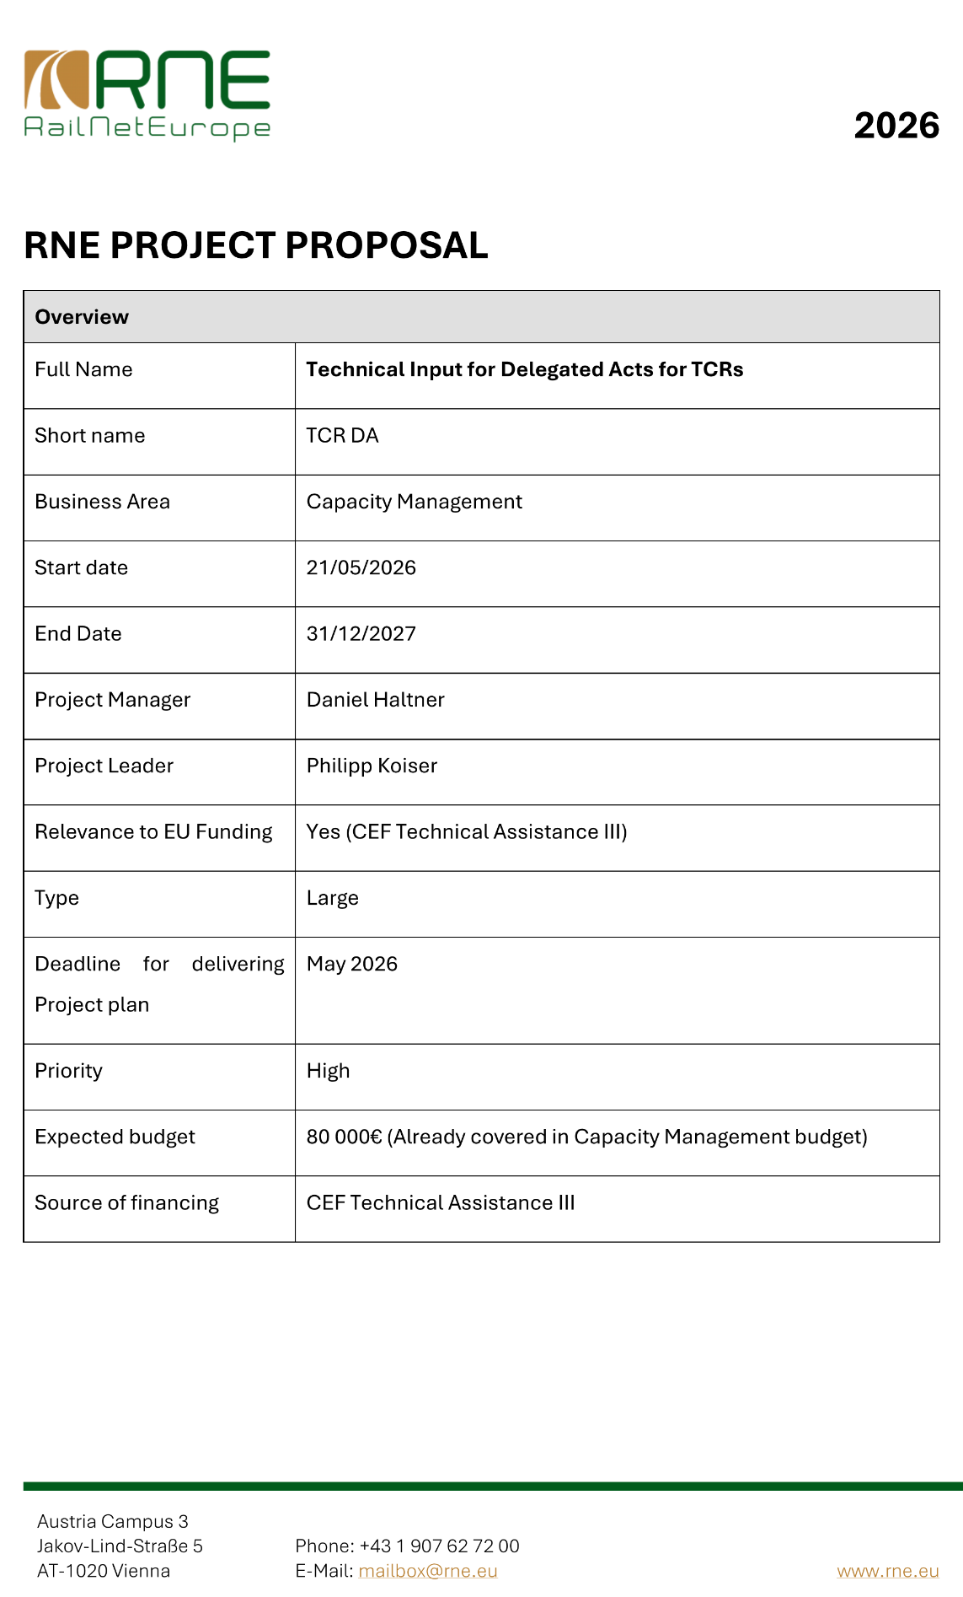
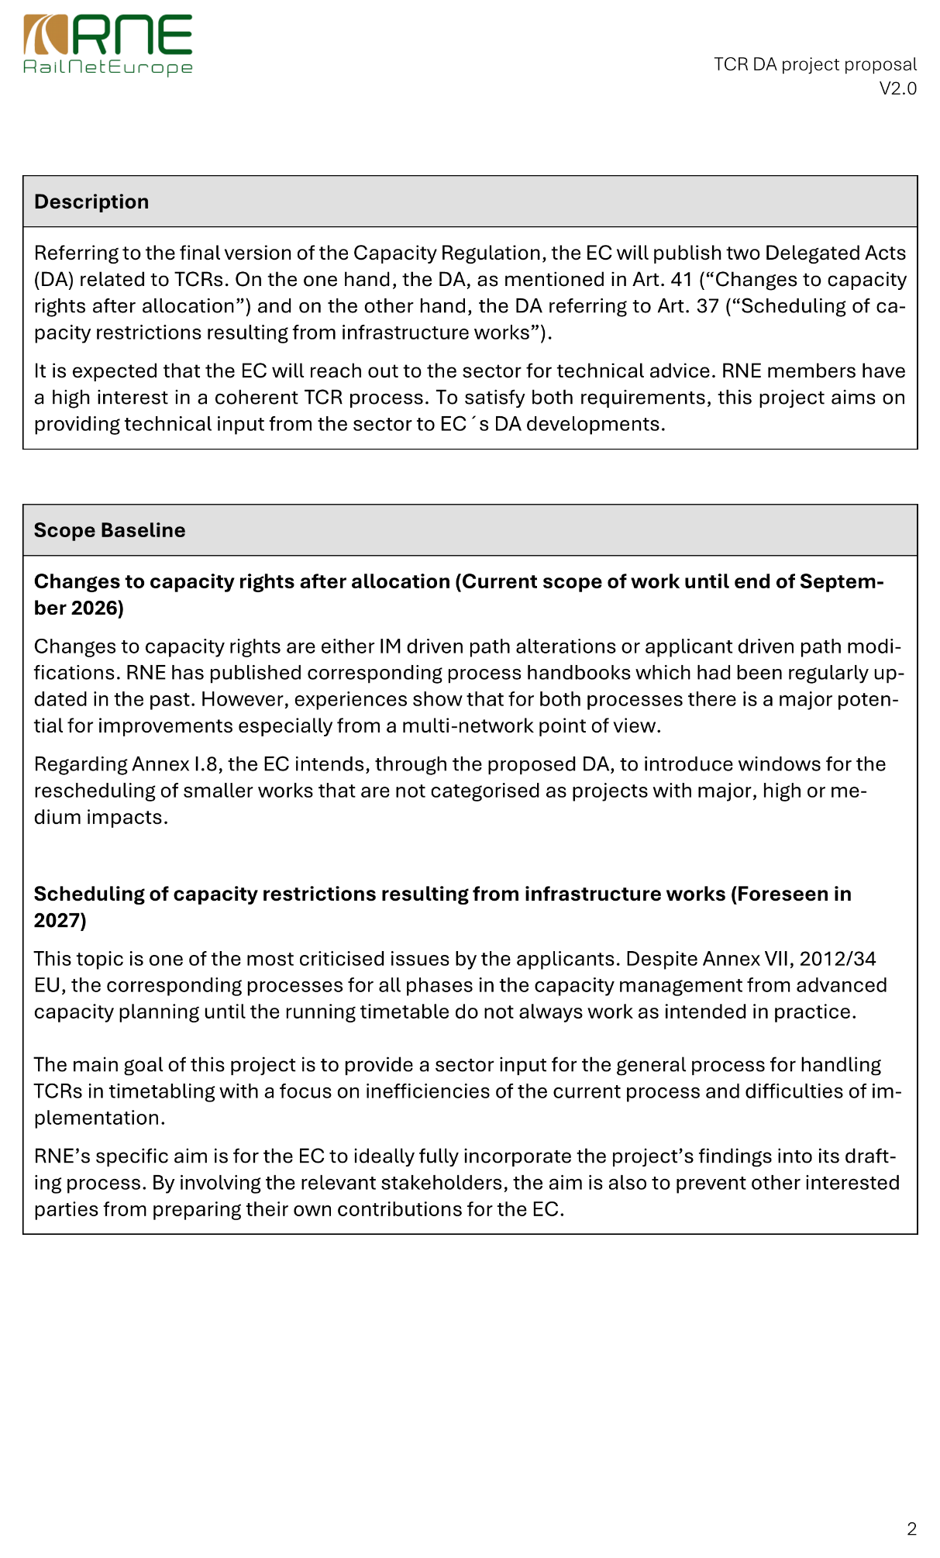
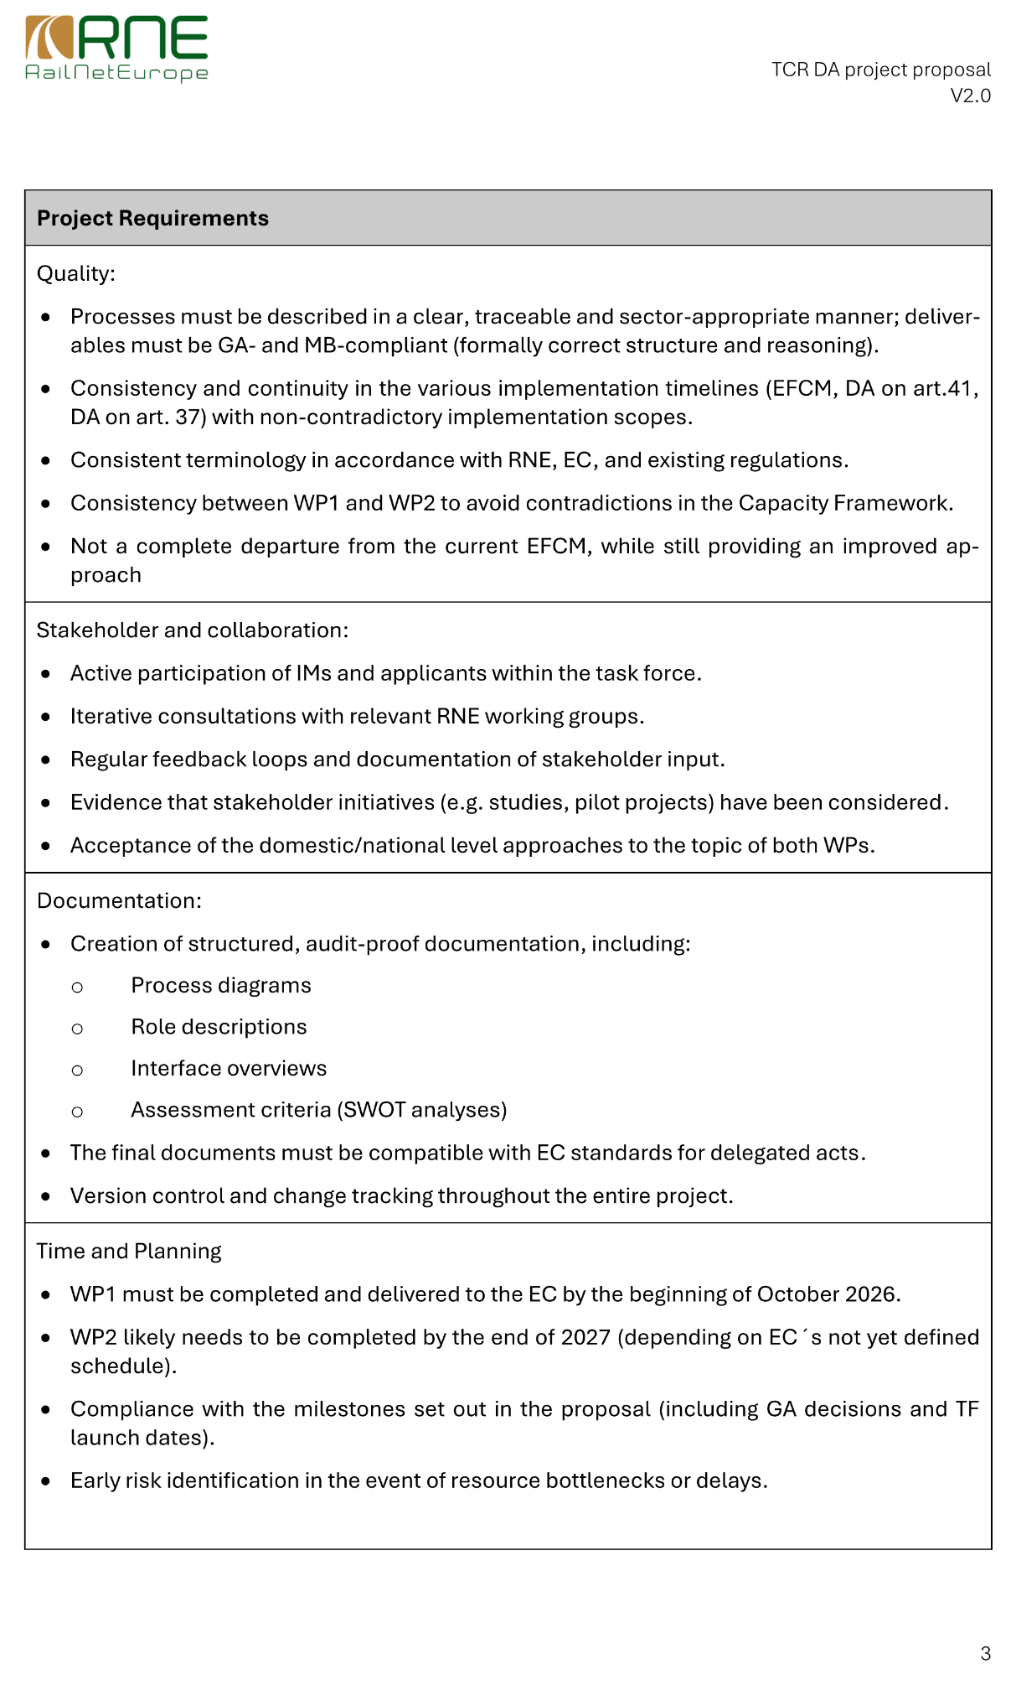
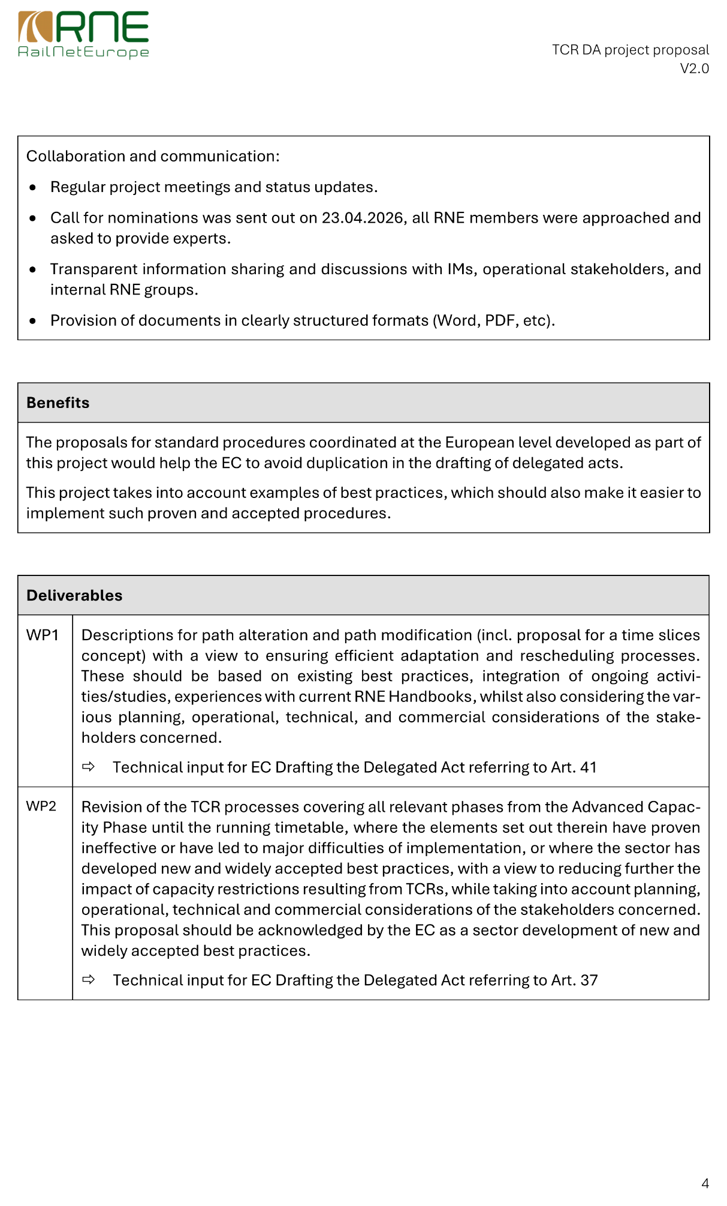
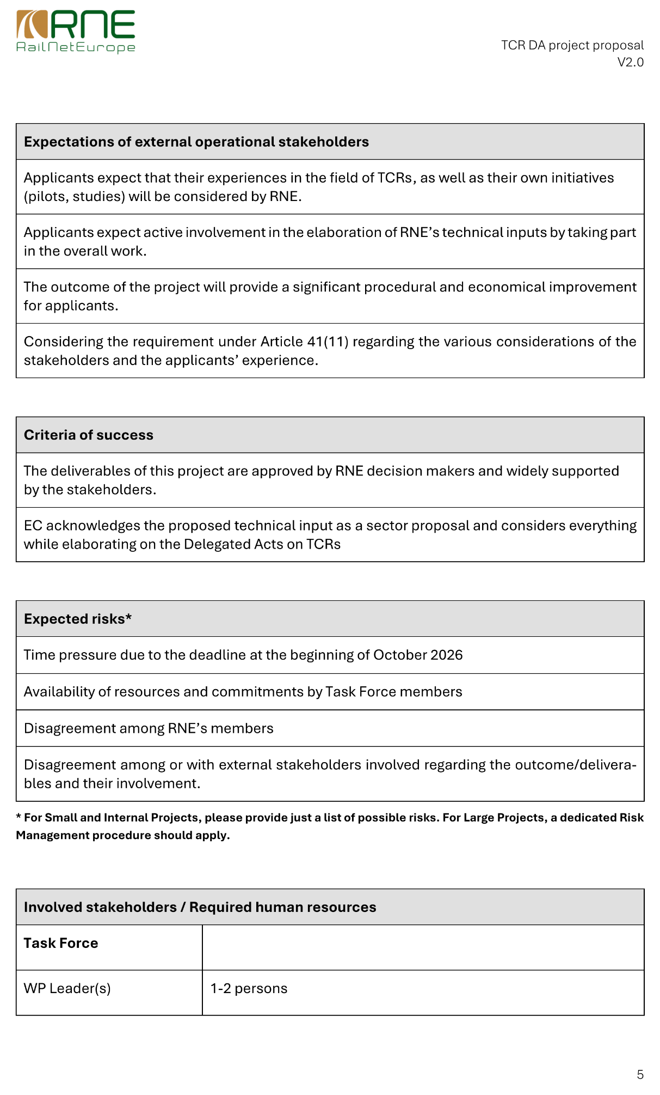
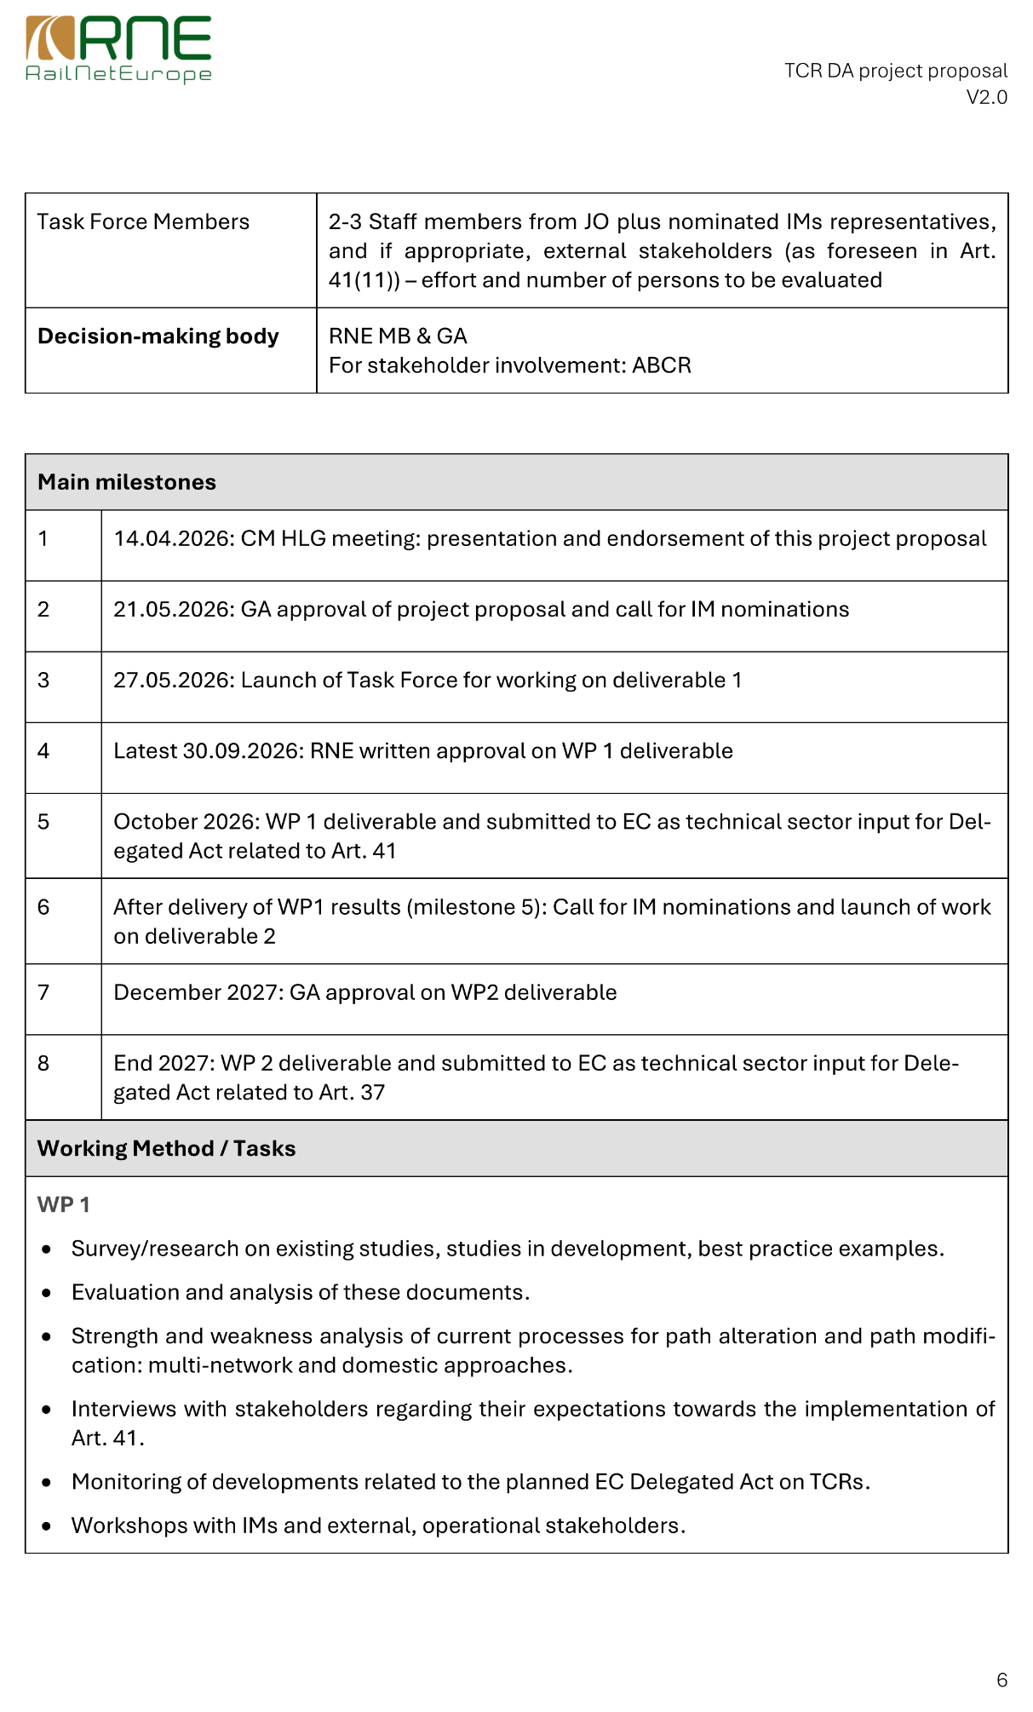
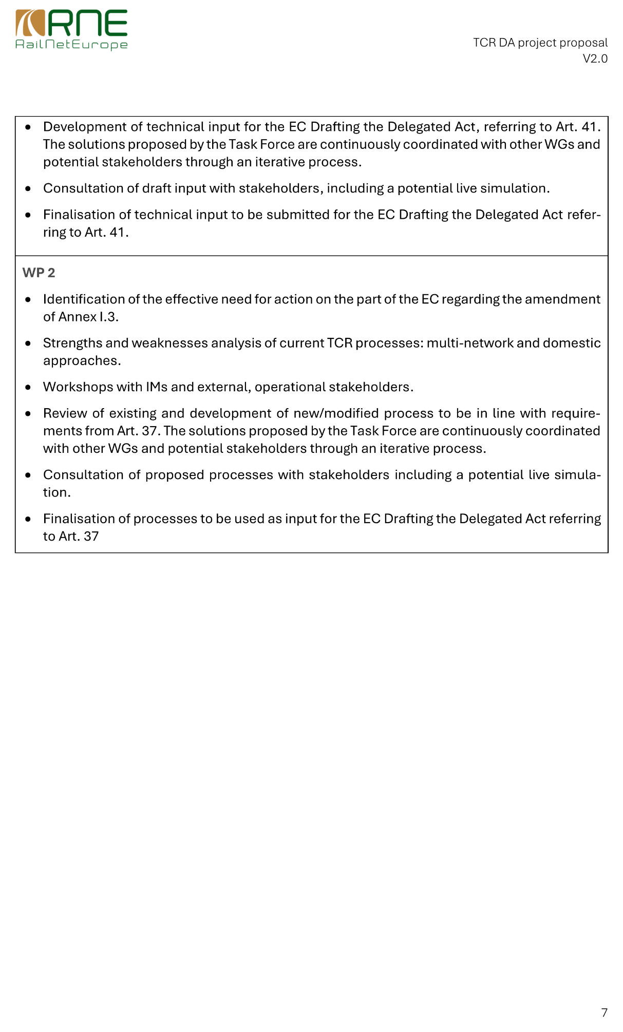

Pending the adoption and publication of the regulation in the Official Journal (https://eur-lex.europa.eu/), see the most recent publicly available version (Position of the Council at first reading with a view to the adoption) at https://data.consilium.europa.eu/doc/document/ST-16833-2025-REV-1/en/pdf, classified as interinstitutional file 2023/0271 (COD).
In accordance with the legal definition in Article 5(3) of the capacity regulation.
The scope of the present mandate-driven collaboration is limited to work package 1 of the global project; see page 3 of the project proposal in Annex I.
Available at https://rne.eu/wp-content/uploads/ABCR_Terms-of-Reference_2026-04-27.pdf.
The duration of the collaboration may be extended as a result of the preparations on the delegated act. At this stage, RNE does not have confirmed information in this regard. The participants will be kept up-to-date on any developments.

