Functional handbook

INCIDENT MANAGEMENT in TIS 2020

RailNetEurope
Oelzeltgasse 3/9
AT-1030 Vienna
Phone: +43 1 907 62 72 00
mailbox@rne.eu
www.rne.eu

Table of Contents
1 Introduction 3
2 About Incident management tool 4
2.1 Usage - Business case 4
2.2 User management 5
2.2.1 User roles 5
2.2.2 User rights 6
2.2.3 User preferences 7
2.3 Translation management 8
3 Main functions – functional specification of tool 10
3.1 Define interruption 11
3.1.1 Interruption definition page 12
3.1.2 Preview function 15
3.1.3 Finalisation of Interruption definition 17
3.2 Interruption message list 18
3.2.1 E-mail notification about Interruption 19
3.3 Overview of Interruptions 20
3.3.1 View / Edit Interruption 21
3.4 Overview of affected trains 23
3.4.1 Displaying options – company layout 24
3.4.2 Affected train information 25
3.4.3 Editing of affected trains 28
4 Additional functions 32
4.1 TIS 2020 Trains page 32
4.2 Train search function 33
4.3 Train Info page 34

Introduction

The Incident Management tool was developed in order to support the communication between IM dispatching centres in case of interruptions. The tool is the successor of the previously known Park or Run tool and is also partially replacing the TCCCom tool, as far as event related communication is concerned.

The purpose of this handbook is to explain in detail all the functions of the Incident Management tool and should serve as basis for the discussion about further improvements. This handbook can also be used by national IM experts to get to know the tool and thus being able to offer the training to their traffic control centre staff.

The information about the basic TIS 2020 functions can be found in TIS 2020 user manual here:
https://cms.rne.eu/system/files/tis_2020_user_manual_6.pdf. To every Incident management tool user, it is also recommended to study the TIS 2020 manual or to see the video tutorial here: https://cms.rne.eu/tis/content/tis-videos-0.

About Incident management tool

The Incident Management tool (IMT) was developed within the TIS 2020 system, so already collected real time information within TIS 2020 are used to automatically feed IMT with necessary information.

Usage - Business case

The primary goal of the Incident Management tool is to record the information about interruption into TIS 2020, so it is visible to all users. Depending on the status of the interruption, 2 different scenarios can occur:
- Scenario 1: Need to only share the information about interruption and its consequences
- Scenario 2: Need to agree also on the treatment of affected trains – trains to be parked

Depending on the scenario, when interruption is defined, user either “PUBLISH” or “NOTIFY” interruption. Detailed functionality is explained within chapter 3.1.4.
Scenario 1:
- Serve to only information exchange – previous TCCCom functionality
- Treatment of affected trains not to be communicated via TIS 2020
- Affected trains identified only for the notification purposes
- Interruption recorded by pressing “NOTIFY” button
Scenario 2:
- Used when there are some trains foreseen to be parked
- Communication about treatment of affected trains done via TIS 2020 – previous Park or Run functionality
- Affected trains identified and loaded to Overview of affected trains (3.4)
- Interruption recorded by pressing “PUBLISH” button
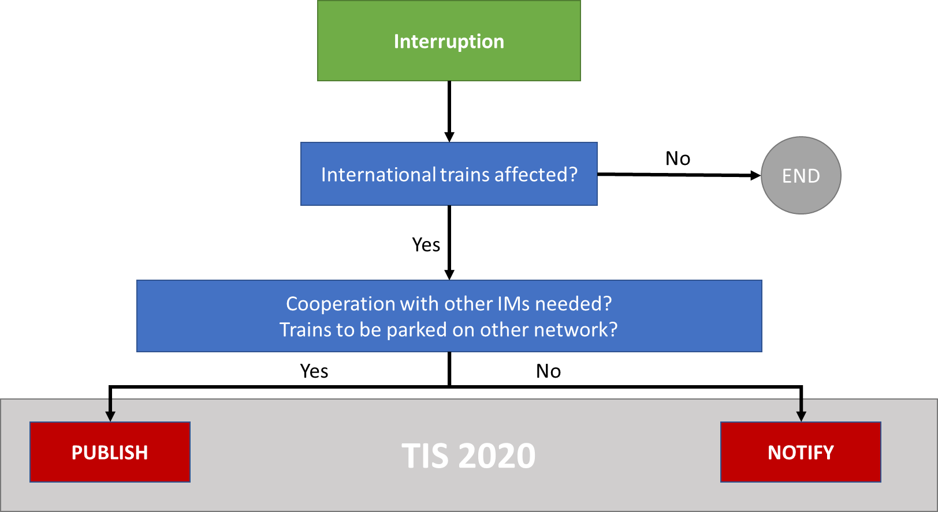

User management
The user management for IMT is following the general principles for TIS 2020 user management.

The general administration is done by RNE Joint office, which allocates the national admin rights to TIS 2020 National administrators. The allocation of different IMT user roles and rights is done by National Admins.

The national admin can give to his users either the user role – predefined combination of user rights – or the single user rights. For the purpose of IMT, it is recommended to give only the predefined user roles (not the user rights).

User roles
There are 2 different user roles predefined in the TIS 2020:
- Publish Interruptions
- View Interruptions

Publish Interruption role
This user role is for the dispatching staff, which will work with the tool.

This role covers the following rights:
- View Interruptions,
- Receive Interruption Notifications,
- Edit Own Interruptions

View Interruption role
This user role is for any other users (both IM or RU), who are interested in seeing the IMT information in TIS 2020 or receive the notification about the recorded interruption.

This role gives the user the following rights:
- View Interruptions,
- Receive Interruption Notifications

User rights
The following user rights are available in TIS 2020 related to IMT tool:
- View interruptions
- Edit own interruptions
- Receive Interruption Notification
- Save Company Default Layout for Affected Trains
There are 2 additional user rights defined in TIS 2020:
- Edit interruptions
- View own interruptions
These ones are specific rights for administrational purposes only and are not to be given to single users.

View interruptions

This is the basic right to enable the user to see all Incident management relevant information in the TIS 2020. User right does not give the user any possibility for editing.

User with this right is able to:
- See the Overview of Interruptions
- See the Overview of Affected Trains
- Display interruptions and filter on affected trains in:
  - Map overview,
  - Space time diagram,
  - Connection diagram,
- See the history of train treatment in Train Info Page

Edit own interruptions

This user right is the basic right for using the full functionality of IMT.

User with this right is able to:
- Define, Edit and Close interruption for his network (Publish and Notify the Interruption)
- Edit the trains in the Overview of affected trains

Receive interruption notification

This user right serves to identify the users to which the e-mail notifications related to interruptions can be send. Only users with this right will be able to receive the e-mail notification.

Save Company Default Layout for Affected Trains

This user right enables the user to define the company default table layout for the Overview of affected trains. More information about this function can be found here: 3.4.1

User preferences

Each user has a possibility to check his user rights, change the password, enter additional personal information and predefined the language in which he would like to use TIS 2020 system in the User preferences submenu:

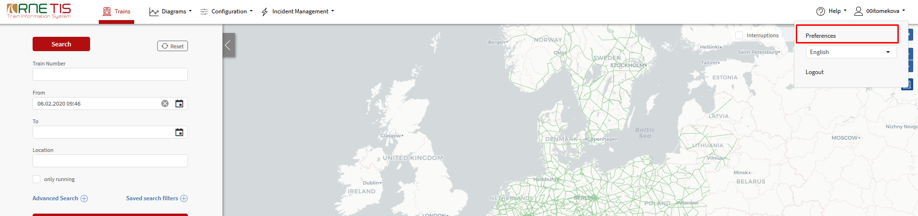

The Incident Management e-mail notifications,are sent to the user in the laguage as defined in user preferences:

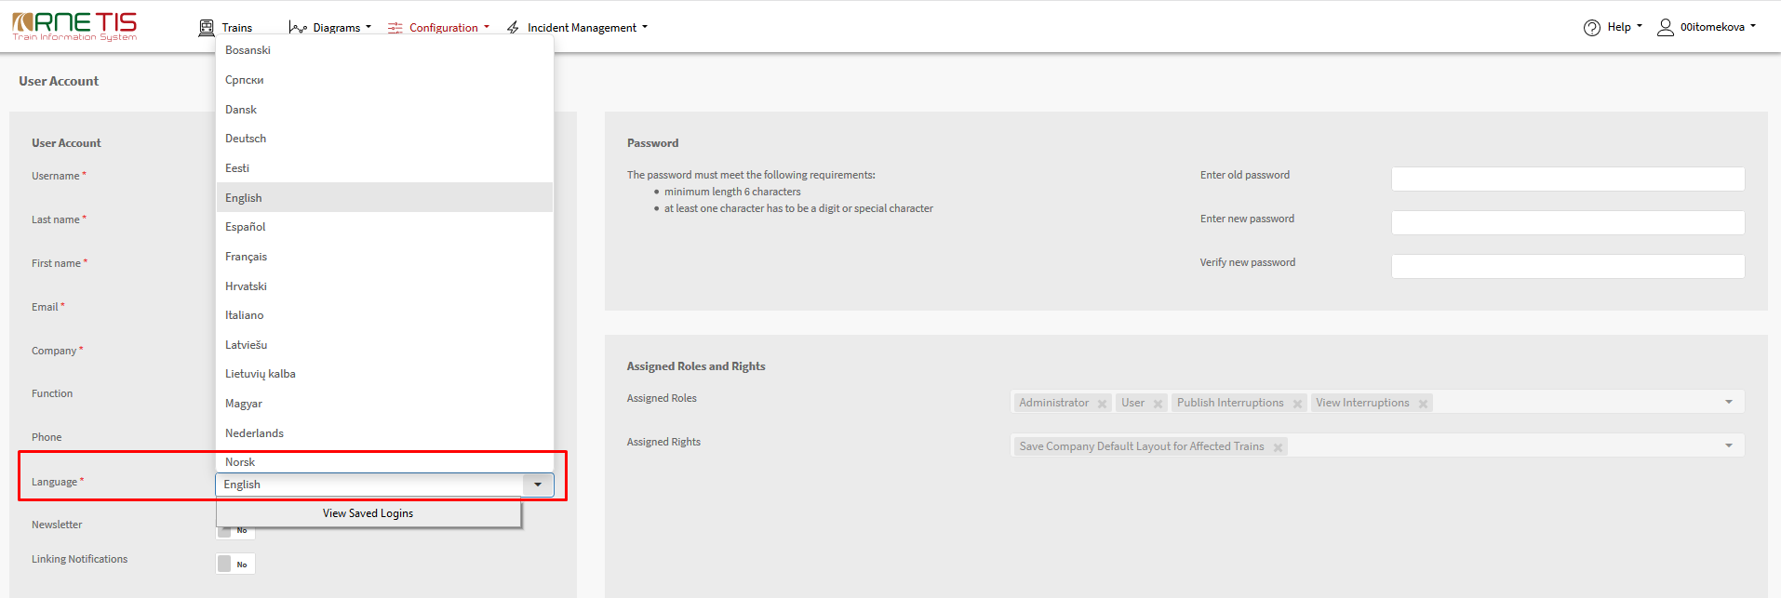

Translation management

TIS 2020 is primarily developed in English. Each IM has a possibility to translate TIS 2020 to his national language. For this purpose, the TIS 2020 Translation management function can be used by users with the specific user right, usually the National Admin.
To ensure the translations for the Incident Management tool are available in TIS 2020, user should go to TIS 2020 submenu Configuration – Translation Management:
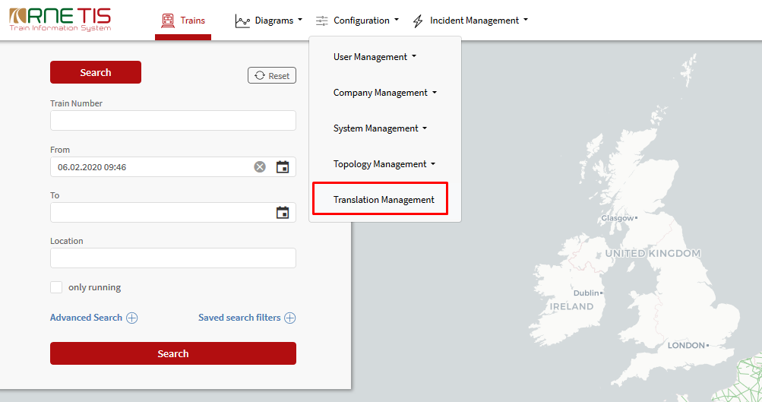
In the translation table, first the language for which translations are to be made must be chosen:
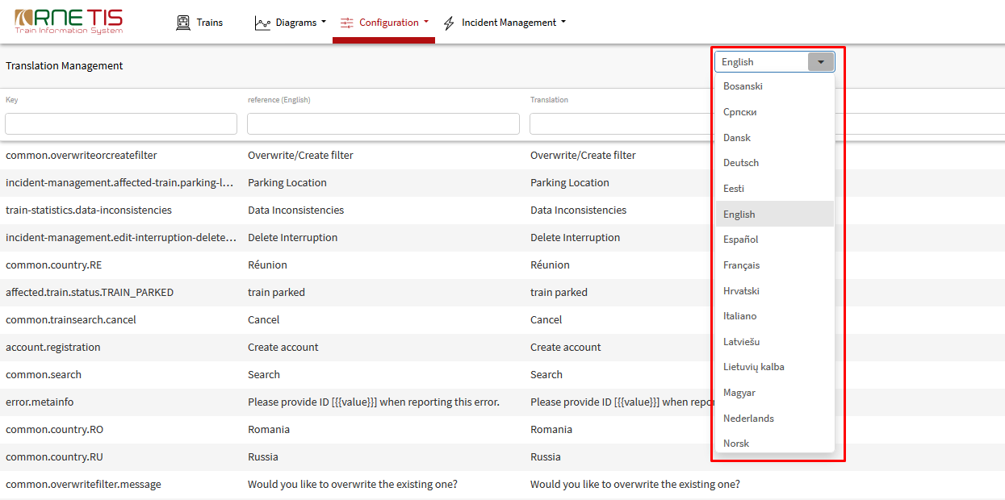
To filter all Incident Management tool related expression, the “incident-management” should be written to the column Key:
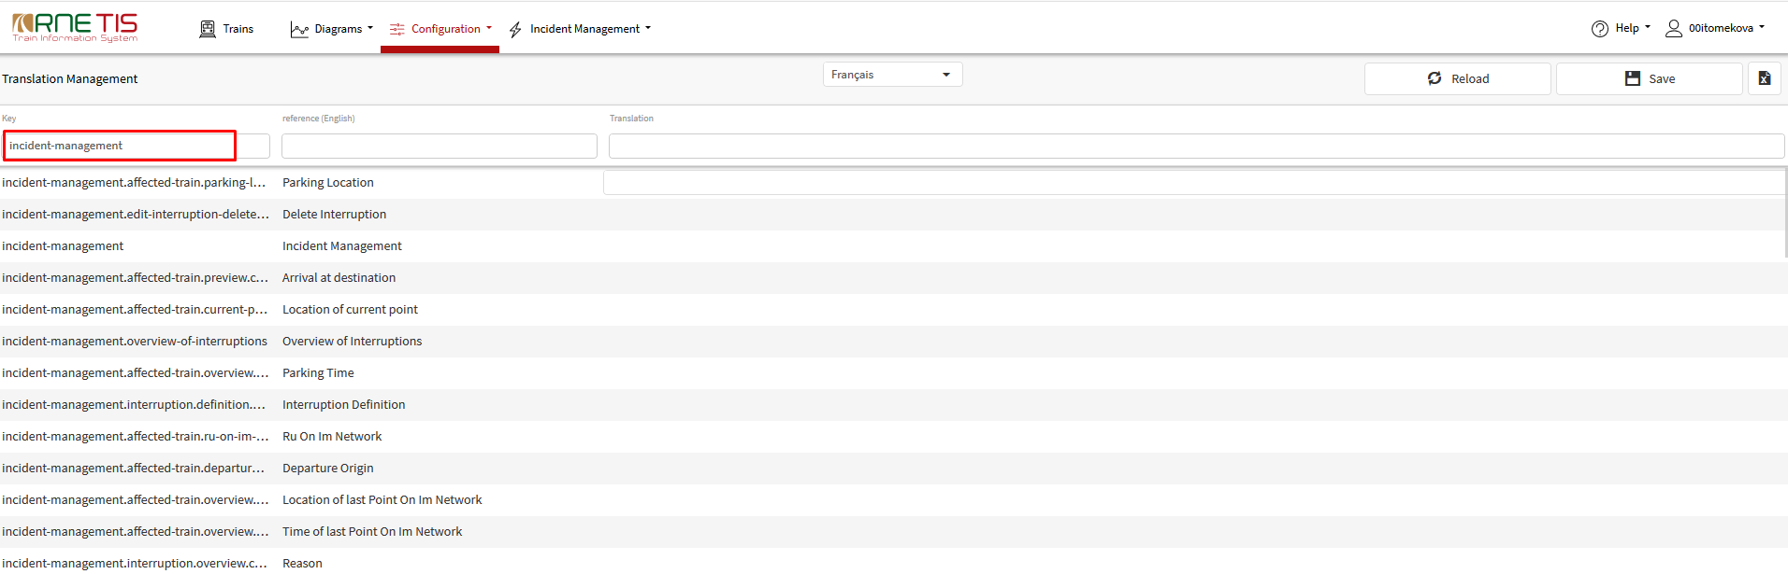
The translation text should be entered to the column Translation and then the Save button should be pressed:
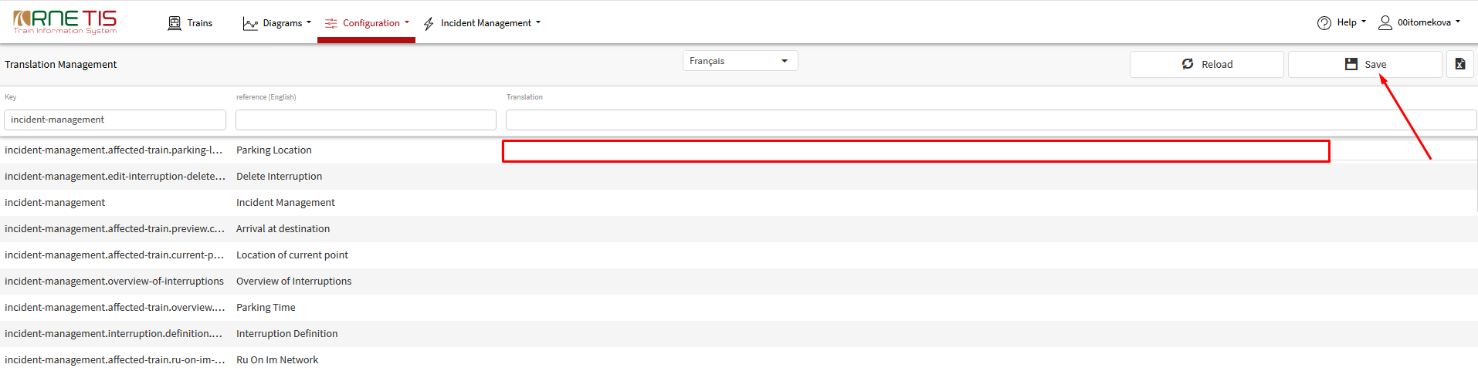

Main functions – functional specification of tool

To cover all needed functions related to Incident Management and to make the tool easy and friendly to use, the distinct menu for Incident management can be found in TIS 2020 (as shown on the picture below):
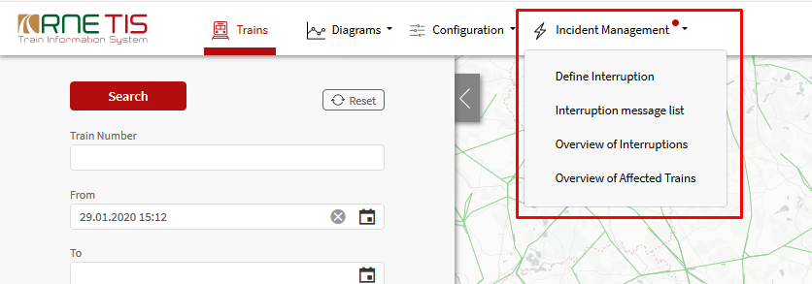

This menu offers the following submenus:
- Define Interruption
- Interruption message list
- Overview of Interruptions
- Overview of Affected Trains

Define Interruption - interface to record the information about interruption

Interruption message list – list of all received notification messages

Overview of Interruptions – overview about all recorded interruptions and their impact

Overview of Affected Trains – overview of all currently affected trains

Define interruption

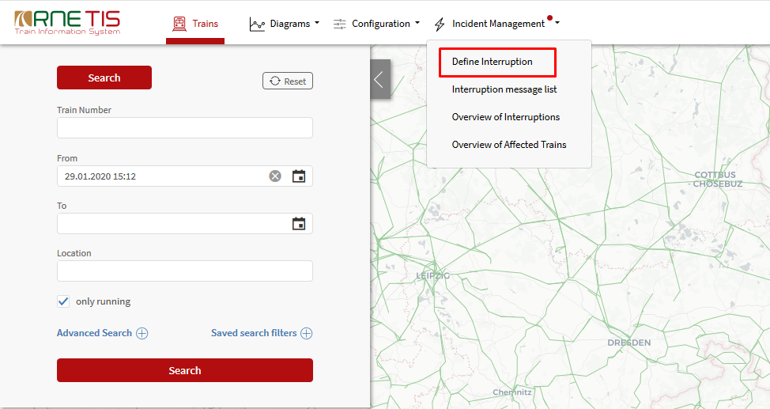

When the user selects the menu item "Define Interruption" a form is displayed where the user can insert all necessary information about an interruption. The user can define an interruption only for his own network.

After all information are filled in, user press the Preview button. In the Preview user sees the list of affected IMs, the list of affected RUs and list of affected trains. User can manually add additional IMs and RUs to the list. Only user with receive notification right of the IMs and RUs chosen in the list will received the e-mail notification about the interruption. In the list of affected trains, user can specify the status for the listed trains. Statuses given in this list will be included in the e-mail notification but will not be transferred to the Overview of affected trains.

When the user completes the data insertion, the user can record the interruption either by pressing PUBLISH or NOTIFY button.

When Publish button is pressed, notification about interruption is send out, the interruption is recorded in TIS and displayed in all other TIS functions (space time diagram, network overview, train info page, etc.) and affected trains are recorded to the overview of affected trains.
When Notify button is pressed only notification about interruption is send out. No affected trains are recorded to the overview of affected trains.

Interruption definition page

An interruption is defined by the following fields:
- Status of interruption:* Open, Solved (available only for published interruptions), Closed
- Estimated Duration of Interruption: From-To*
- Affected Train types:* Freight, Passenger, Other
- Location of Interruption: * Single point or Whole network
- Description of Interruption:* predefined list of possible causes
- Consequence of Interruption:* from No impact to Total closure
- Additional Information: Line section, Exact location, Affected border stations
Fields marked with * are mandatory.
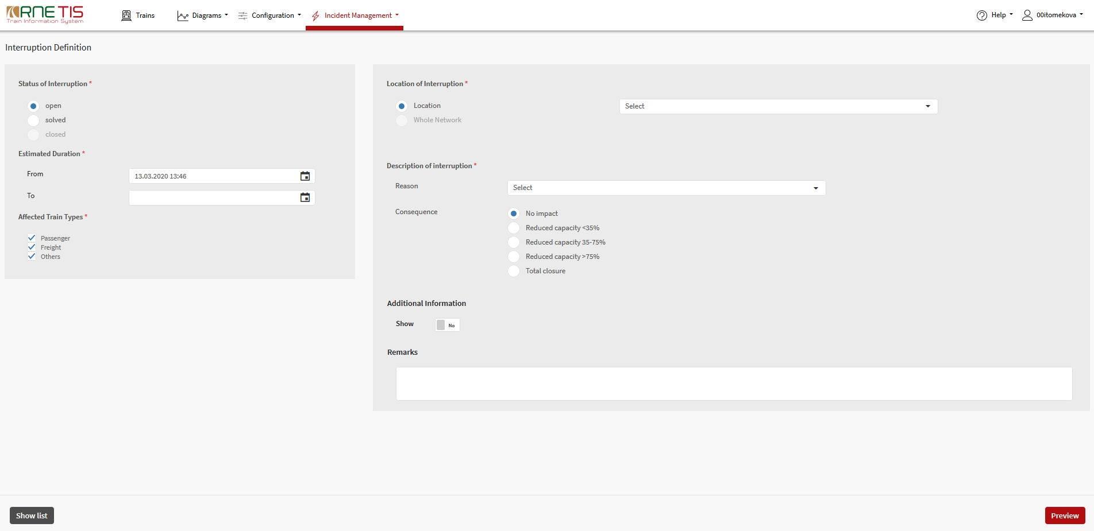

Status of interruption – mandatory

Three different status are possible:
- Open
  - For any new interruption and also for interruption which is still valid.
  - Status “Open” is filled in as default value when defining the new interruption.
- Solved
  - In case the interruption is already solved (Full capacity available again)
  - Solved does not mean, that all trains affected by interruption are already running. Consequences of interruption could last longer than interruption itself. Solved is only meant for information purpose to inform, that interruption is not existing any more, interrupted track/network is available again.
- Closed
  - If the last affected train is ended/solved, the interruption will be closed automatically by the system
  - status “Closed” can only be given automatically by system

Location of interruption – mandatory

As a location of interruption either Whole network or the single location can be specified.

For Location of Interruption, based on the user profile, the list of IM relevant TIS points is offered using the autocomplete list. As a location point, only TIS points can be used, otherwise system would not be able to automatically identify affected trains. Each user is able to define the interruption only for his network.

In case interruption occurs in between 2 TIS points (or in point not defined as TIS point), user has to choose the correct TIS point carefully so the right trains are identified as affected.

Autofill in function is working only if at least one character (letter or number) is entered (either few letters of the location name or PLC code numbers). This autocomplete filter works in such a way, that all locations in which the written character is included are displayed (not only locations starting on the entered character). For that purpose, it is recommended to write as many characters, as possible.

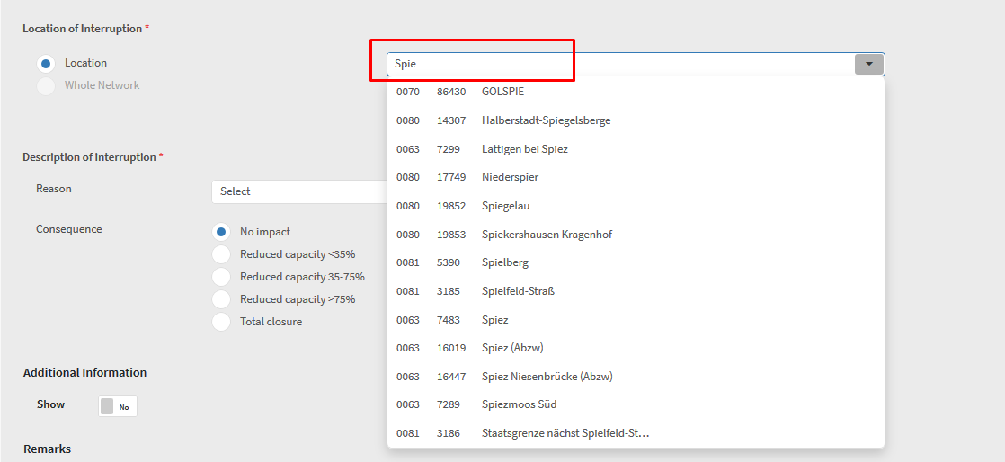

Estimated duration of interruption – mandatory

Two Date&Time values must be given – starting time (From) and ending time (To). This estimation must be given to identify the affected trains within the timeframe. Both starting date&time and ending date&time values are mandatory. The time box for start (FROM) is filled in with the actual time by default but is editable; the end value (TO) is empty by default. When the date is chosen from calendar, the time 23:59 of the chosen date is given by default but can be overwritten.

Affected train types – mandatory

User must specify, which train types are affected by interruption (passenger, freight, other). By default, all train types are chosen.

Description of interruption - mandatory

To describe the interruption, drop down list with predefined descriptions is used.

Following descriptions are included in the drop-down menu:
- Railway accident
- Personal accident
- Track obstruction
- Unplanned maintenance or construction works
- Malicious act
- Fire
- Snow
- Flood
- Tempest
- Failure of track
- Failure of signalling equipment
- Failure of electric power supply
- Telecommunication system breakdown
- IT system break down
- Industrial action (strike)
- COVID-19
- Others

Consequences - mandatory

Following optional buttons are available:
- No impact
- Reduced capacity < 35%
- Reduced capacity 35-75%
- Reduced capacity >75%
- Total closure

Only one of them can be chosen. This information is serving only for information purposes and has no impact on identification of affected trains.

Remark – optional

Free text field for possible remarks is included as an optional field. This text is not translated and therefore it is recommended to use English language for the remarks.

Additional information – optional

If needed, user can specify any additional information concerning the location of interruption. This information serves only information purposes and has no impact on identification of affected trains.

Providing the additional information can be activated by pressing the “No” button:
Following information can be provided:
- Detailed information on location – to specify one or several Line sections
  - Activated by pressing “ADD” button
  - Line from / Line to – as autocomplete list of all TIS locations
  - If activated, then mandatory
- Exact Location – to inform about exact location
  - As free text field
- Affected border stations – to specify one or several affected border stations
  - As autocomplete list of all TIS locations
  - If activated, then mandatory

Preview function

This function informs the user about the impact of the defined interruption as identified automatically by the system. The main purpose of the page is to give user the possibility to check the detailed consequences of defined interruption before it is recorded and send out to all involved parties.

Following information are provided in Preview:
    - Number of affected trains identified by the system
    - List of Affected IMs as identified by TIS
    - List of affected RUs as identified by TIS
    - List of affected trains as identified by TIS
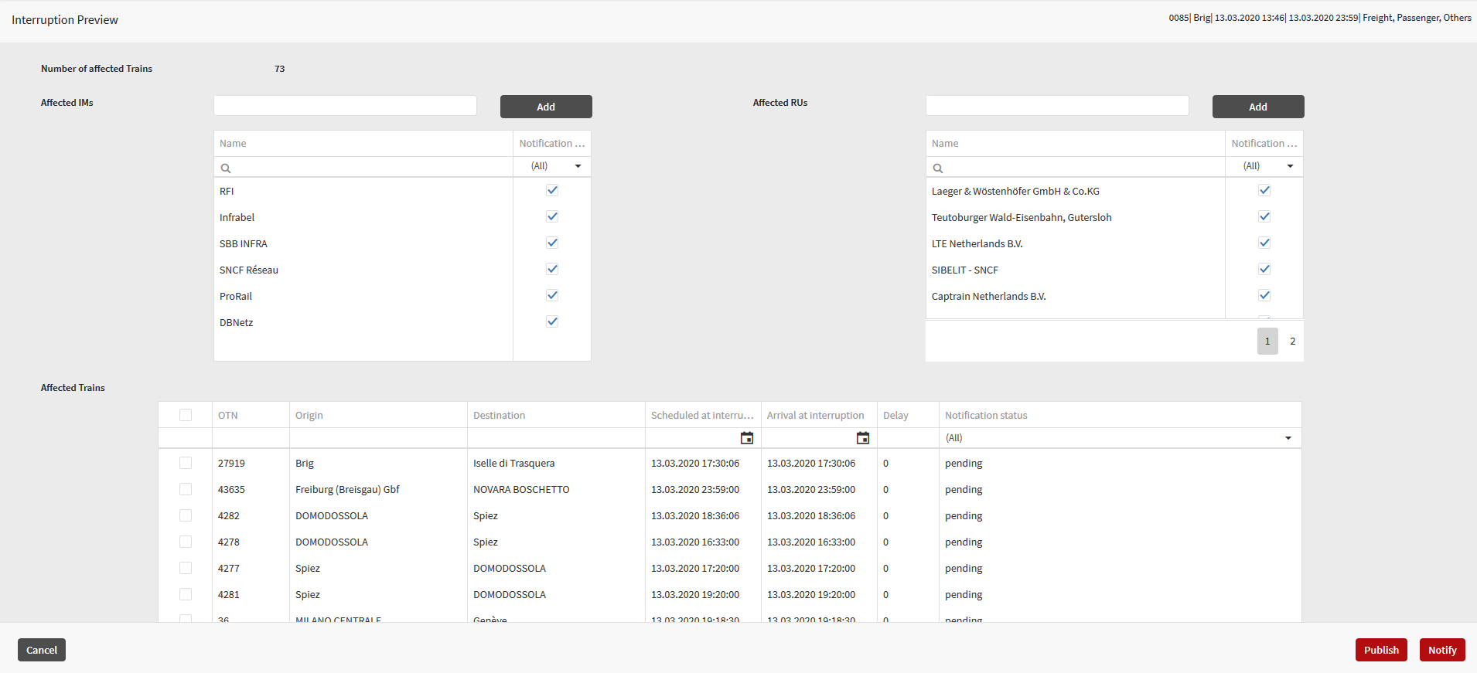

Identification of affected trains

Pressing the Preview button trigger internal TIS process of identification of affected trains. All trains foreseen to pass the interruption point within defined timeframe of interruption are identified as affected. This includes also the trains currently present in the interruption location.

Trains to be marked as affected has to fulfil the following criteria:
- One of following information is available for interrupted point or at least one point of interrupted network (in case of network interruption) and within defined timeframe:
  - Timetable information for point/network and no running information
  - Running information with only status arrived (no departure)
  - Timetable information with actual delay (forecast)
- Type of train should be the same as the one chosen during the Interruption definition

List of affected IMs and RUs

In the overview of affected IMs, all Infrastructure Managers, on whose territory the affected trains should have run are displayed.
In the overview of affected RUs, TIS displays all Railway Undertakings, that are affected by the interruption and involved in the train run of at least one affected train.

By default, all IMs and RUs are selected to receive the e-mail notification about the interruption. The user has the possibility to de-select certain IMs/RUs who should not receive the notification. There is also the option to manually add additional IMs/RUs that were not automatically identified as affected.

NOTE: Only those users from the affected IM or RU company will receive the notification, that have the user right Receive Interruption Notification!

Company code or company name should be entered into the editable field and then autocomplete list is offered. To add the IM/RU into the list, the “ADD” button should be pressed:
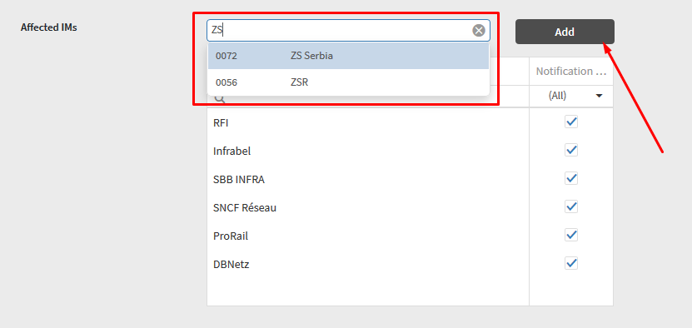

List of affected trains

A preview of all affected trains is displayed in the ‘Overview of Affected trains’. By default, all affected trains have the status ‘Pending’ and are not reported in the e-mail notification.
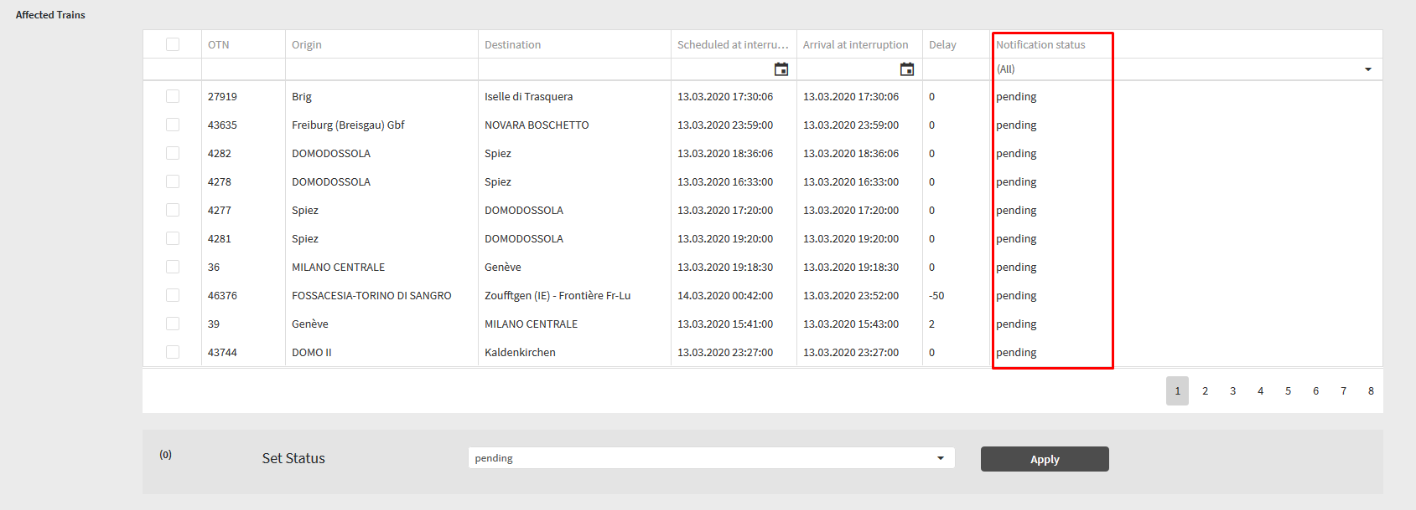

The user can indicate the different statuses for individual trains:
- Delayed
- To be cancelled
- To be rerouted
- Bus service

To change the status of train or several trains, user should activate the check box, Set the correct status from drop down list and press the Apply button.

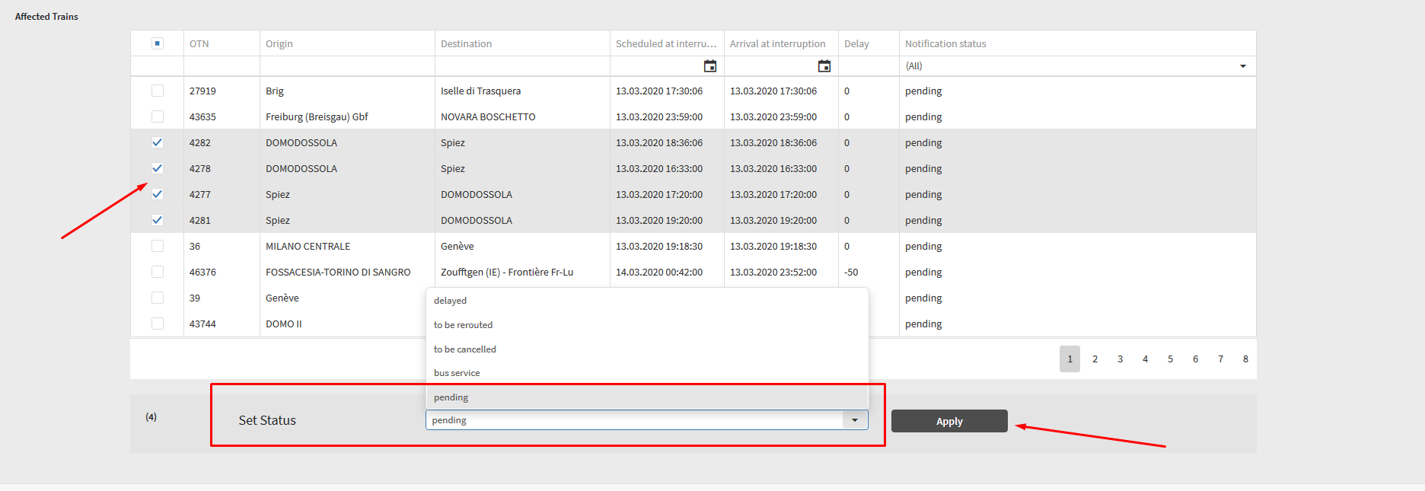

These statuses will be included in the e-mail notification but once the trains are added to the ‘Overview of affected trains’, their status will revert to ‘Pending’. Only trains with status other than ‘Pending’ will be included in the e-mail notification.

The list of affected trains will be included only in the e-mail notification to the IM users. E-mail notification to RU users will not have any list of train included (as the filter to display only the trains of the users would have to be included).

Finalisation of Interruption definition

When the user completes the data insertion, the user can finalise the interruption definition either by pressing PUBLISH or NOTIFY button. Pressing one of these buttons triggers internal TIS processes:
- Interruption is given an ID and is recorder into Overview of Interruptions
- TIS and E-mail notifications are sent
- Affected trains are recorded to the Overview of affected trains (in case of “Publish” button)

Publish interruption

This button should be pressed in the cases, when further communication with cooperating partners concerning the treatment of affected trains is needed: when there are some trains which might need to be parked.

When Publish button is pressed, notification about interruption is send out, the interruption is recorded in TIS and displayed in all other TIS functions (space time diagram, network overview, train info page, etc.) and affected trains are recorded to the overview of affected trains.

Notify interruption

This button should be pressed in cases, when user would like to just share the information about the interruption and handling of affected trains on his network and no further communication about treatment of affected trains is foreseen with cooperating partners.

When Notify button is pressed only notification about interruption is send out. No affected trains are recorded to the overview of affected trains.

Interruption message list

In case new interruption is defined and also in all cases when already defined interruption is changed (e.g. updated timeframe, change of status), TIS 2020 notification to all relevant partners is sent.

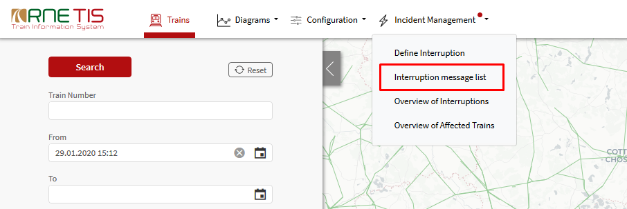

Interruption message list provides the overview of all received notifications. If there is a new notification, not yet read by the user, the red light icon appears next to the Incident Management header:

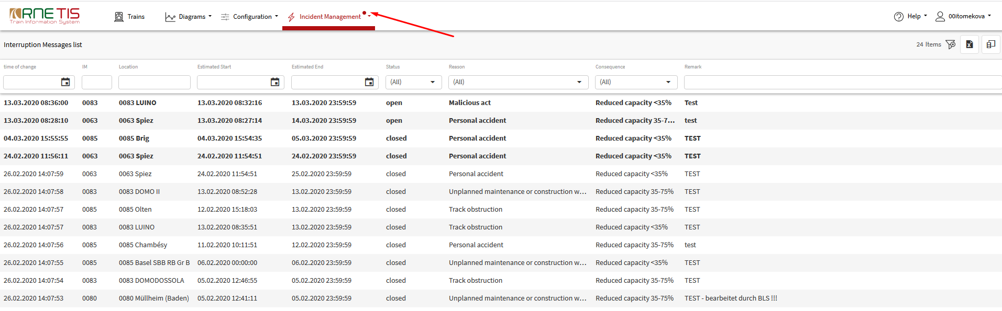

All new notifications are displayed in bold letters. To mark the notification as read, the double click anywhere in the row belonging to interruption should be made.

E-mail notification about Interruption

In addition to notification within TIS 2020, the notification is sent also via e-mail. All users, having the right to receive interruption notification, will receive the notification to their e-mail defined within TIS 2020 user profile in case their company was defined by interruption owner for notification purposes in the Preview (3.1.2.1).

E-mail notification is sent to the user in the language, which is defined in the user preferences (and in case the proper translation is available in TIS 2020).

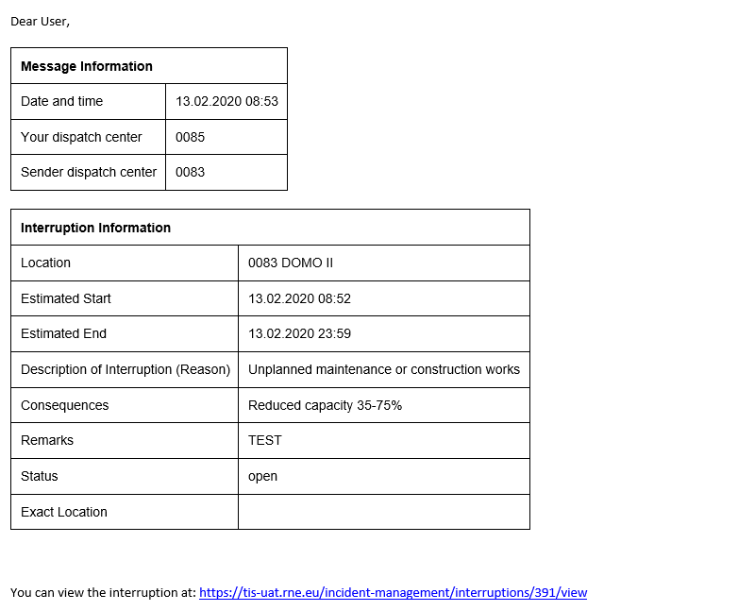

The list of affected trains will be included only in the e-mail notification to the IM users. E-mail notification to RU users will not have any list of trains included.

Overview of Interruptions

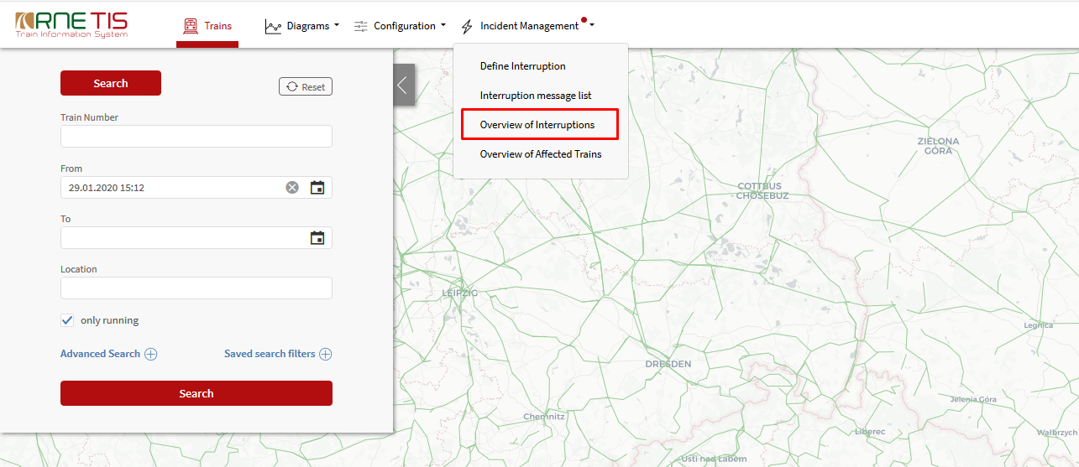

Overview of Interruptions provide the basic overview of already recorded interruptions as well as their impact on the traffic.

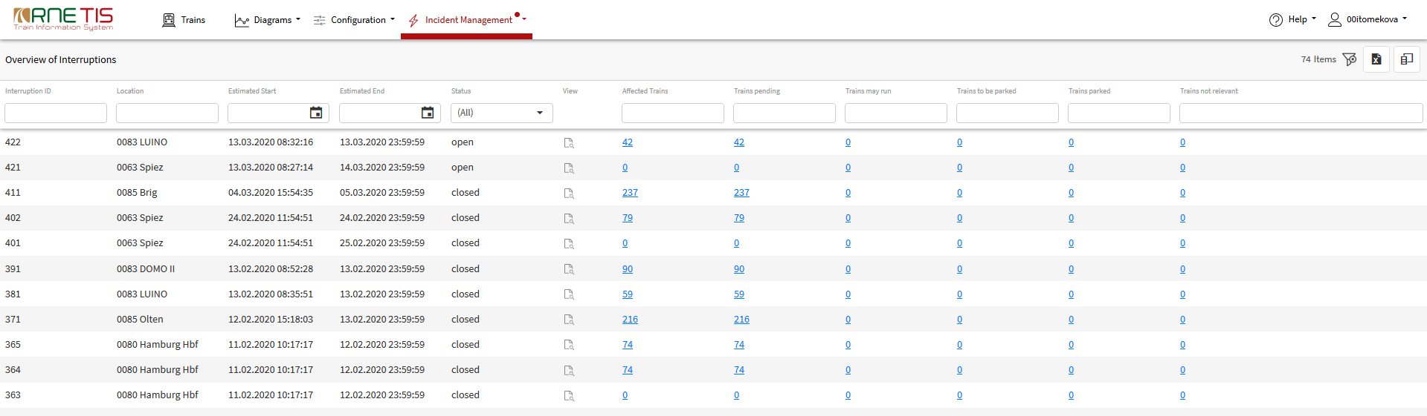

The information displayed in the overview are:
- Interruption ID
- Location of Interruption
- Duration
- Status
- Amount of affected trains (in total and also for each status separately)

In the default display the interruptions are ordered based on their status (open, solved, closed) and based on the interruption ID (newest first).

The amount of affected trains and amount of trains for the different status (blue numbers), are showing, how many trains are affected by interruption in total and which statuses they have. It is NOT the IM / RU specific number and thus this number does not represent the amount of trains that are displayed in the Overview of affected trains for the user.
If no numbers are displayed for certain interruptions, this means that there are no trains affected by this interruption because interruption was defined only for notification purposes – not published.
The numbers in the table serves as the hyperlinks to the Overview of affected trains. When the overview of affected trains is opened, the automatic filtering is applied:
- Only trains for this specific interruption are displayed (Interruption ID)
- Only trains with the specific status are displayed (Pending, May run, etc.)

View / Edit Interruption

To view and edit the details of the already recorded interruption, the „View“ icon in the Overview of interruptions should be clicked:
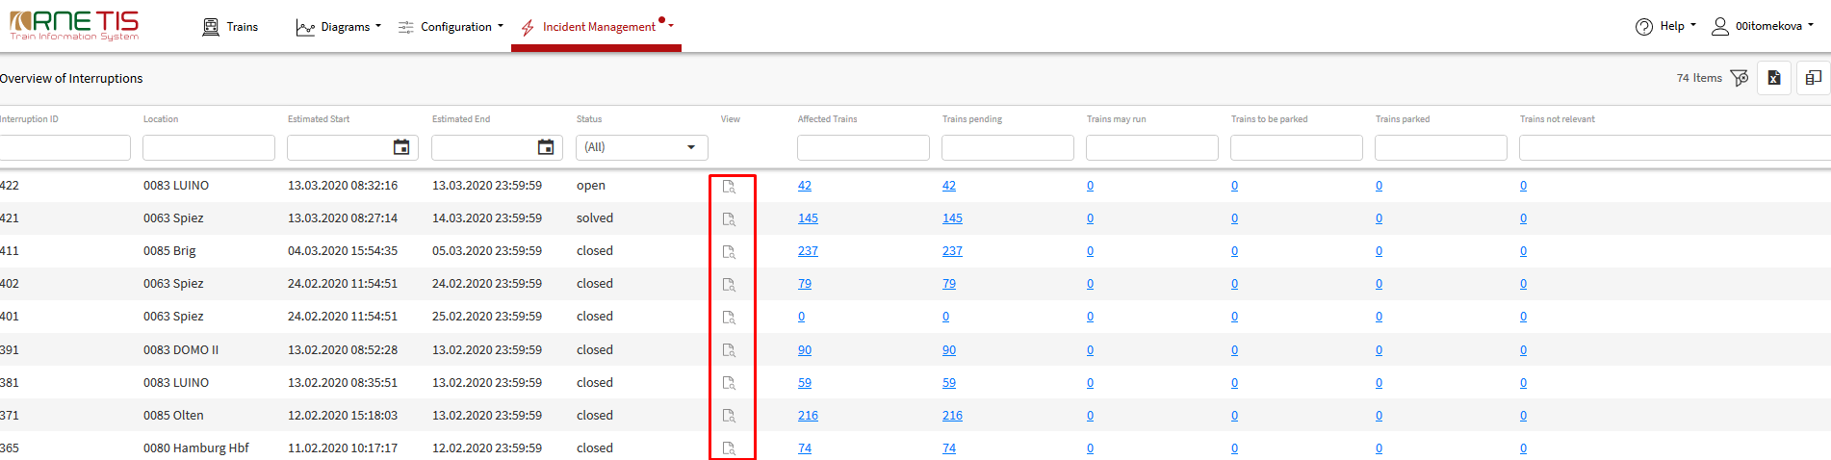

After clicking on the „View“ icon, the Interruption definition page is opened.

To edit the interruption, the „Edit“ button should be pressed.
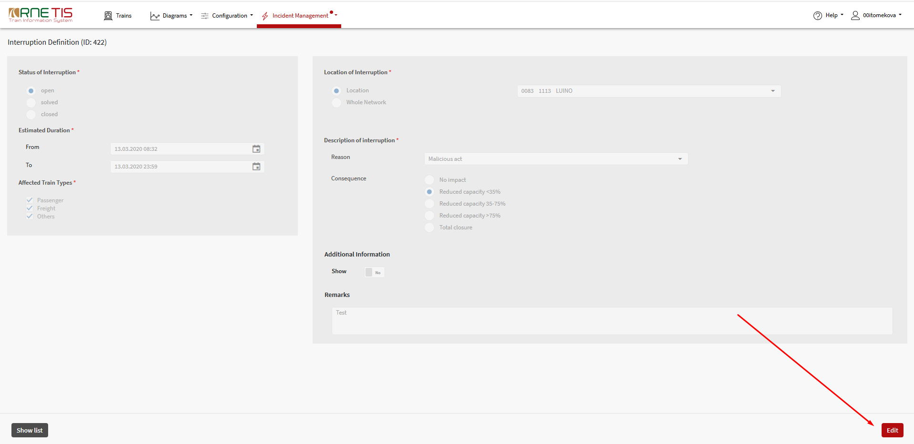

Edit button is activated only for those users, which are allowed to edit the interruption:
- Users having the right Edit own interruptions
- Users belonging to Interruption owner (company that originally defined the interruption)

During editing, only following information may be updated:
- Status
- Timeframe (only prolongation)
- Description
- Consequences
- Additional information
- Remark

Update of Location of Interruption is not allowed. Update of Status and Timeframe has an impact on the identification of affected trains, as described in the following chapters. Update of other fields (description, remark, consequences, etc.) are only to be recorded and included in the notification. Their update has no impact on the identification and treatment of affected trains.

Update of status

As soon, as status “Solved” is given, no other trains affected by this interruption are to be identified. Status Solved is only meant for information purposes to inform, that interruption is not existing anymore.

If the last affected train is ended/solved, the interruption will be closed automatically- status “Closed” will be automatically given by system. Status closed will also be given automatically after X hours from the estimated end of interruption. This timeframe is defined as system parameter.

For each of the closed interruptions, the latest status of list of affected trains can be downloaded.
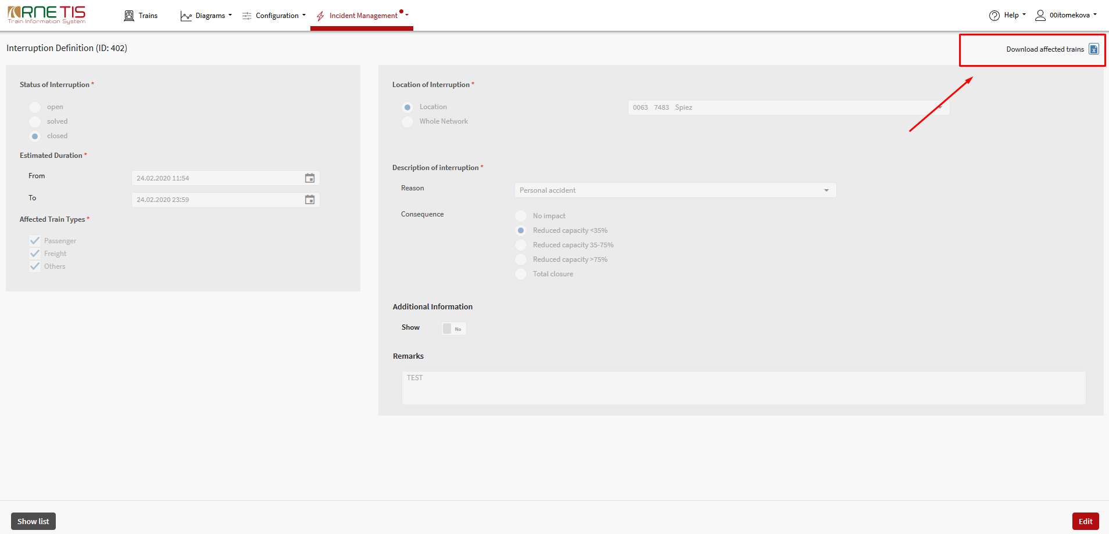

Update of Timeframe

In case, the original timeframe is prolonged new affected trains will be identified for prolonged timeframe (time difference between original time and updated time). Trains already tagged as affected will stay unchanged (not generated again).

The shortening of the timeframe is not allowed. Already affected trains stays as originally defined.

Preview of update

After updating the information about interruption, the Preview button should be pressed. In the preview page, the newly affected IMs, RUs and trains are highlighted.

Overview of affected trains

The list of affected trains can be found in Overview of affected trains within Incident Management menu.

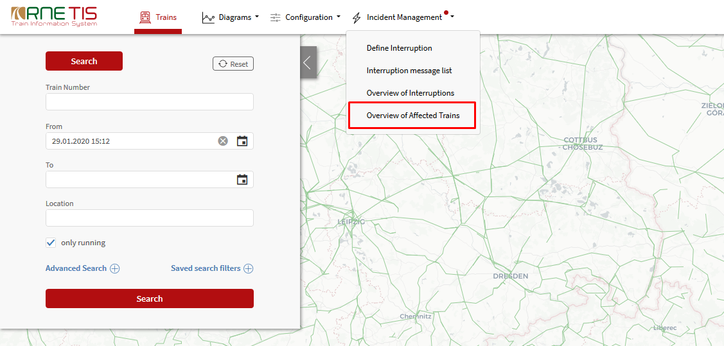

As default view, all affected trains for the logged in user are displayed.

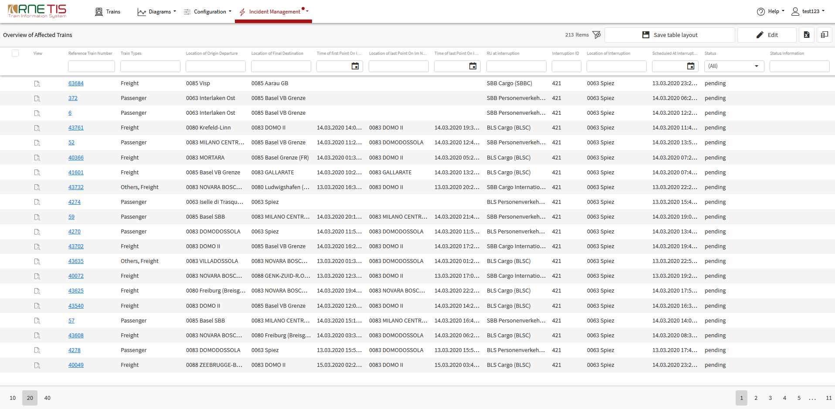

The explanation of the information displayed in each column is explained in more detail in the chapter 3.4.2.

Displaying options – Setting company layout

The overview of affected trains is displayed in the same way for all user from the same company, based on the defined default company layout.

NOTE: Company setting can be done only by user/users with specific user right: Save Company Default Layout for Affected Trains.

When first time using the overview of affected trains, all columns are displayed as default. User can decide, which columns he want to have displayed by clicking on the Column chooser in the top right corner:
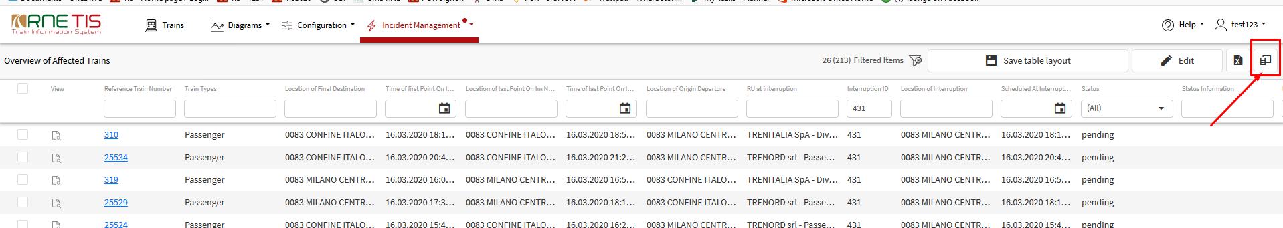

List of available columns is displayed in the bottom right corner and via check box user can choose which columns to display and which not.

The order in which columns are displayed can be changed by dragging the column header and dropping it at desired position.

To save the curren tdisplaying settings as the company table layout, the „Save table layout“ button must be pressed.

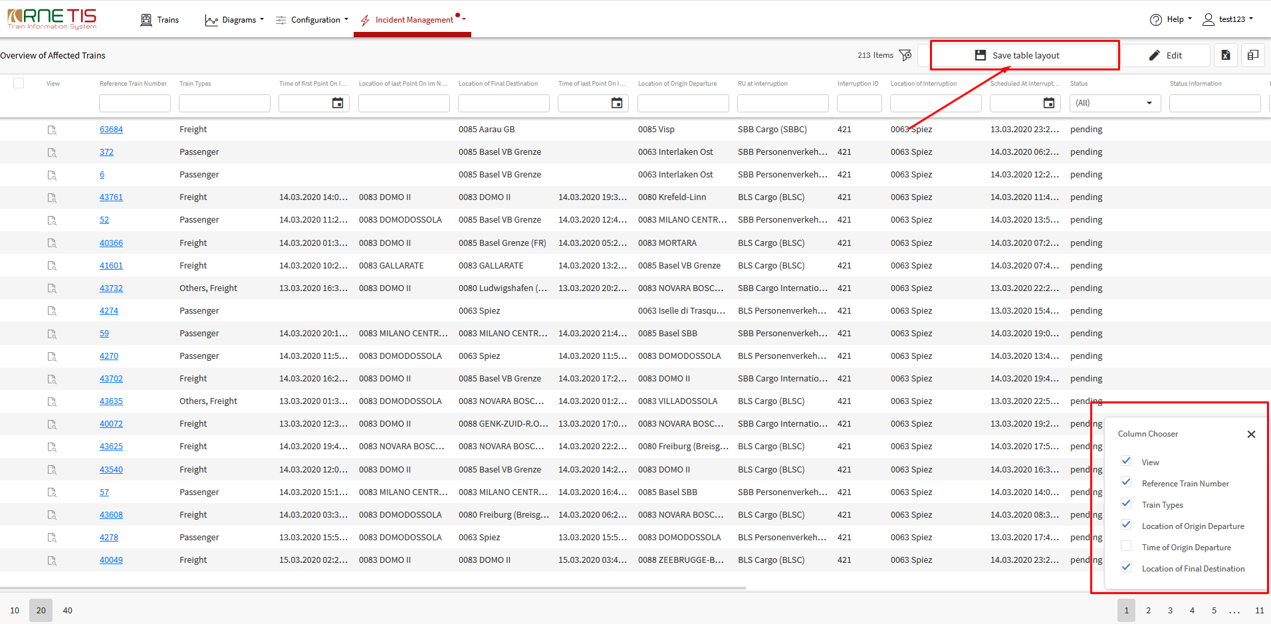

User can also make his own adaptations of the display (visible columns, order of columns, filters, etc.) but currently these user settings are not stored, are applicable only in the current session and will be replaced by default company setting when page will be refreshed. Therefore, it is not recomended to change the order of columns. If user made a change in display settings and want to go back to company layout, the „Load table layout“ button should be pressed (or page can be just refreshed).

Affected train information

To see the detail about affected train, the View icon in the overview has to be chosen.

HINT: To open the information in the new window, press CTRL key and click on the View icon.
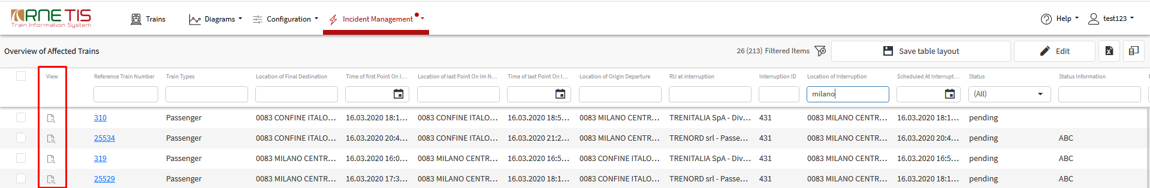

The Affected Train Information page consists of following information blocks:
- Treatment of affected train (editable)
- Train identification (information only)
- User network specification (information only)
- Interruption identification (information only)

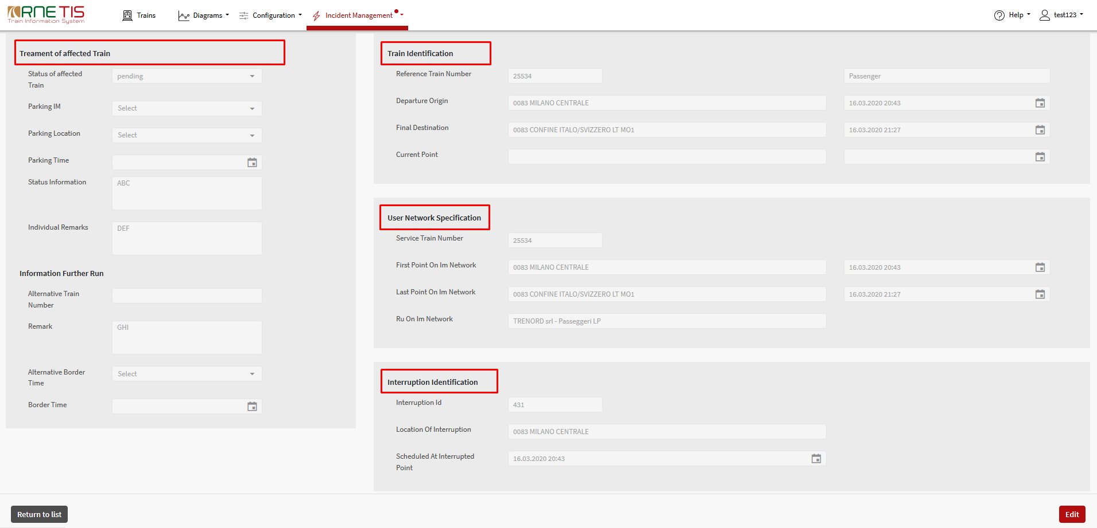

First block of information is displayed on the left side of the page – Treatment of affected trains. This block is the main block used for the communication between dispatching centers. Depending on the certain conditions all fields are editable.

Information blocks on the right side of the page are serving only information purposes and are providing the more detailed general information about train or interruption.

All information provided within the affected train information are also available as the columns in the Overview of affected trains.

Treatment of affected train

The actual information about treatment of the affected train are displayed here:

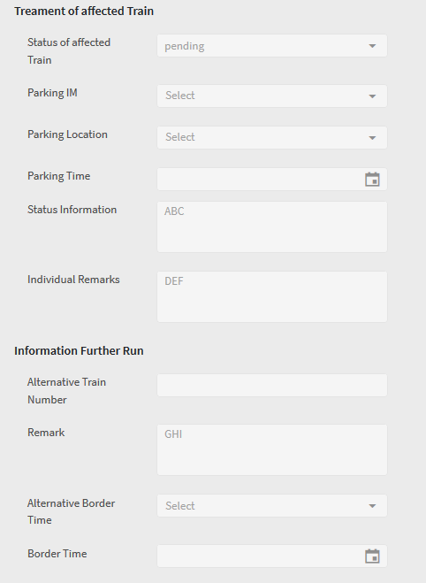

More details about usage of these fields is explained in the chapter 3.4.3.1

Train Identification

This block of information provides the detailed information related to the complete train run:
- Reference train number
- Train type
- Departure origin: location and time (planned)
- Final destination: location and time (planned)
- Current point: location and time (real time + actual delay)

User network specification

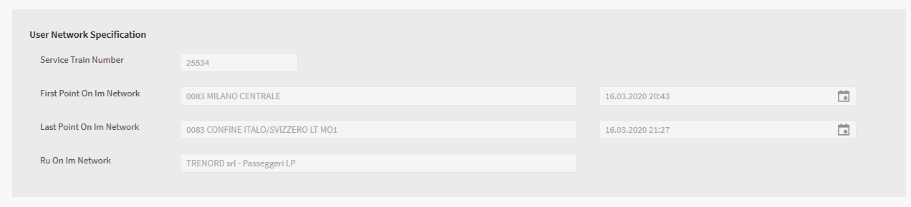
This block of information is user specific and provides the train information related to the user network:
- Service train number (national train number of user IM)
- First point on IM network (origin or entering border station)
  - Location
  - Time (Planned)
- Last point on IM network (final destination or leaving border station)
  - Location
  - Time (Planned)
- RU on IM Network

Interruption identification

This block of information is providing the general information about interruption, such as:
- Interruption ID
- Location of interruption
- Scheduled at Interrupted point
- Date&Time on which the train is foreseen in location of interruption (planned + actual delay)
- In case whole network is affected the interrupted point in this case is the first point within the interrupted network

Editing of affected trains

User can edit only trains affected by interruption on his network or trains for which he is specified as Parking IM. Only trains with available check box in the Overview of affected trains is editable for the user.

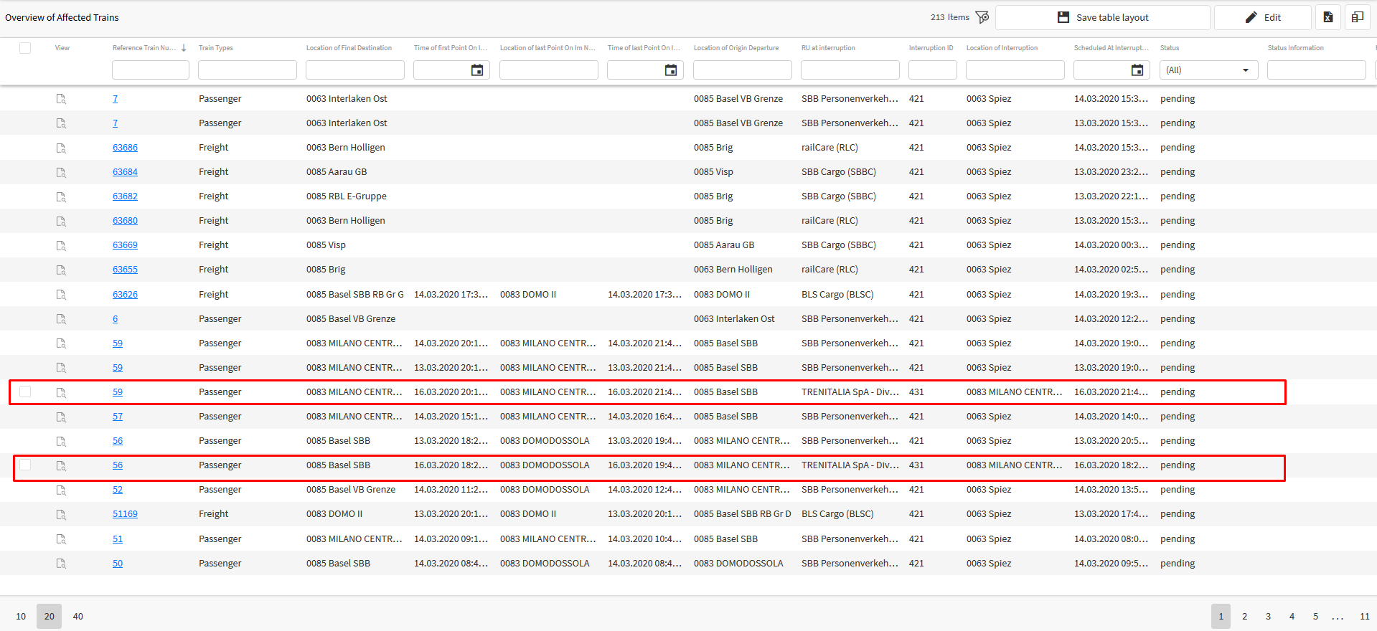

By default, each affected train is having status Pending. The goal of editing of the affected train is to give the relevant status to the train, which will be then visible to all other users. The following statuses can be given to the affected train:
- Pending (by default)
- Train may run
- Train to be parked
- Train parked
- Not relevant

In case several trains listed in the overview May run or are Not relevant, user has a possibility to give them the status using multiple editing function. Trains to be parked or Train parked must be edited one by one.

Editing single train

To edit the single train, the View Icon within Overview of affected trains should be clicked.
HINT: To have train opened for editing in the new window, press CTRL key and click on the View icon.

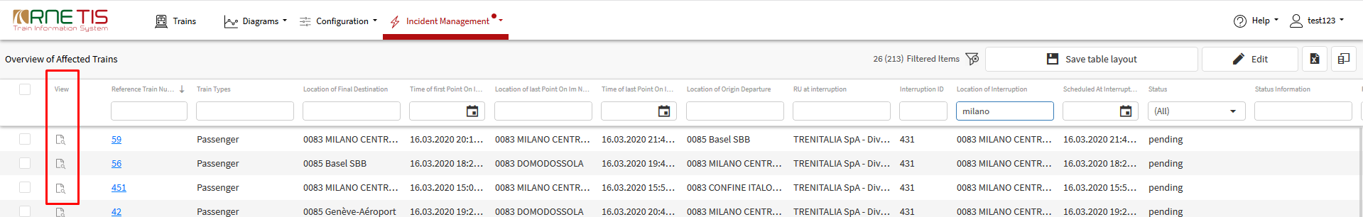

In the Affected train information page, the “EDIT” button in the bottom right corner should be pressed:

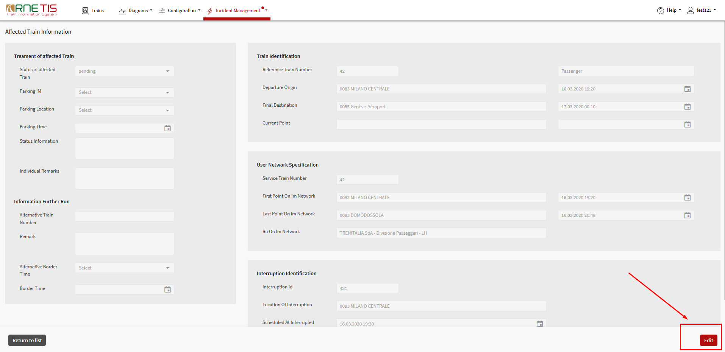

By pressing the Edit button, the train is blocked for editing to other users and the relevant information within Treatment of affected train becomes editable.

Status of affected train
From the drop-down menu, user can choose the relevant status. This information is used for the communication purposes in between the dispatching centers. The meaning of the different statuses is explained bellow:
- Pending – default given by the system; If the train has status pending, this means that so far, the train was not yet treated by the interruption owner or the treatment of this train was not yet decided by the interruption owner
- Train may run – this status means, that there is no specific treatment needed for this train and train can continue to run as scheduled
- Train to be parked – this status means, that train cannot continue to run as scheduled and should be parked
- Train parked – this status means, that train is not running at the moment and is parked
- Not relevant – this status means, that train is not affected by interruption or not relevant for communication purposes

Depending on the status chosen from the drop-down menu, the additional Information are required as follows:
- Status Pending – no additional information needed
- Train may run – no additional information needed, the Information about further run can be provided
- Train to be parked – user should first specify the Parking IM and in case it is his IM, also Location of parking
  - Parking IM – in drop-down menu the possible parking IMs are offered (interruption owner or previous IM)
  - Parking location – autocomplete list of TIS points is offered
- Train parked – user should specify Parking IM, Location of parking and also the Date and time of parking

Independently from the status, the user has a possibility to make 2 types of remarks:
- Status information – as free text, visible to every user
- Individual remarks – as free text visible only to logged-in user (user specific remark)

Information about further run
Following information about further run can be provided by user:
- Alternative train number – to specify the new train number to be used in border point
- Alternative border point – to specify the new border station for handing over the train with new train number
- Time at border point – estimated time at border (original border if Alternative border point box is empty and original train number if alternative train number is empty)
- Comment – as a free text
This information can be provided only together with status “Train may run”.

Editing multiple trains

To edit multiple trains, following steps needs to be made:

1. The trains to be edited must be selected by choosing the check box in the first column
2. “EDIT” button in top right corner must be pressed
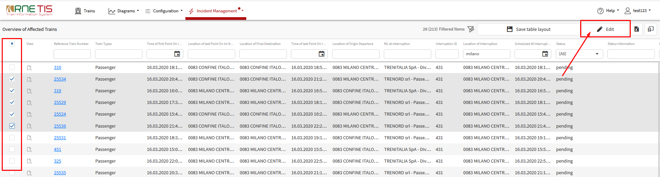

3. In the pop-up window the relevant status should be selected
4. The additional information if needed should be filled in:
- Status information – as free text, visible to every user
- Individual remarks – as free text visible only to logged-in user (user specific remark)
- Remark – as free text visible to every user
5. Press “SAVE” button

After pressing the “SAVE” button, the entered information is recorded to all chosen trains.

Select all function

To select all editable trains, the check box at top left corner can be chosen:

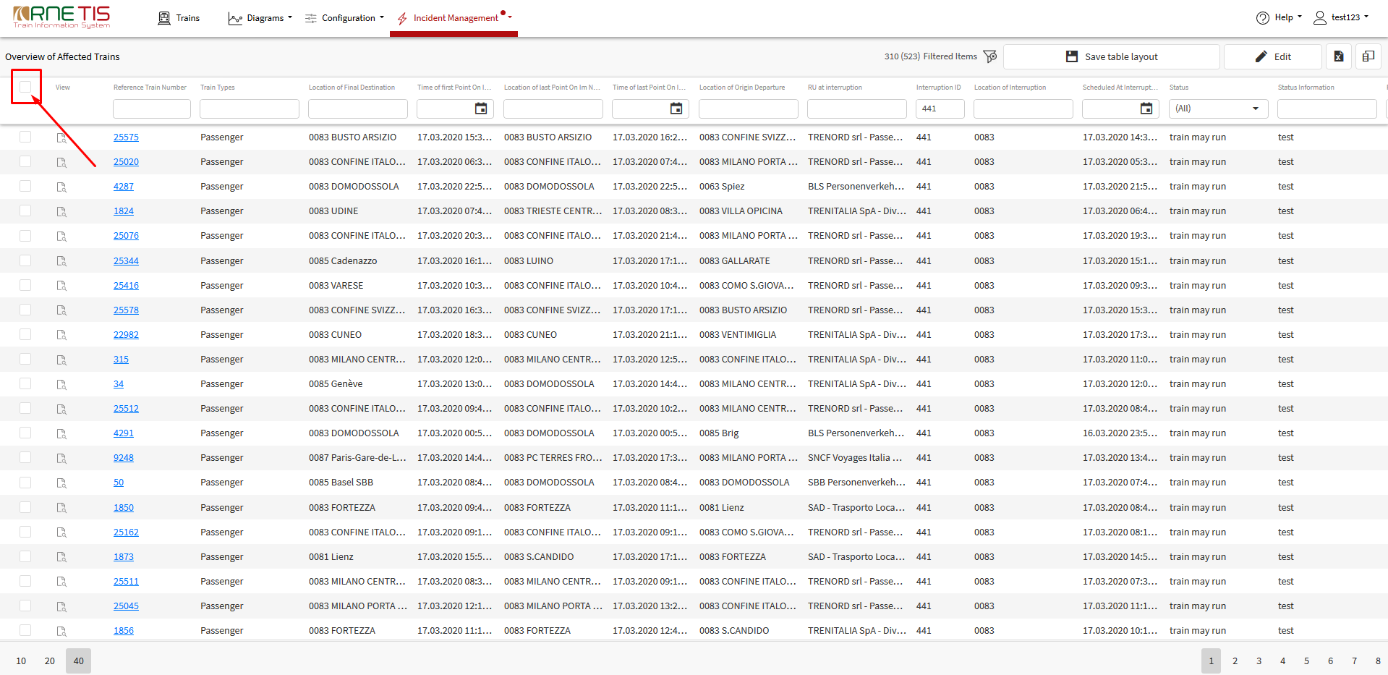

This function is selecting all the trains on all the pages (not just the trains visible on the current page).

Additional functions

Apart from the functions available within Incident Management menu, the information related to incidents (affected trains, etc.) are available also in other TIS 2020 functions.

TIS 2020 Trains page

Information about interruptions can be also found on the main TIS 2020 Trains page. To display the Interruptions on the main page, the check box “Interruptions” should be chosen:

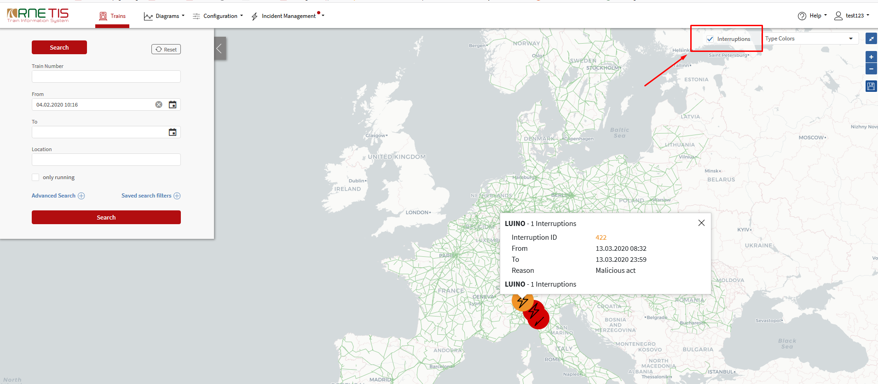

Interruptions are displayed either in red or orange colour:
- In red colour are all “Open” interruptions
- In orange colour are all “Solved” interruptions (with some trains still parked or to be parked) and interruptions foreseen to start in the nearest future (e.g. foreseen strike, etc.)

Train search function

In the main search function, under Advanced search menu, the specific search for affected trains and also for specific statuses can be made:

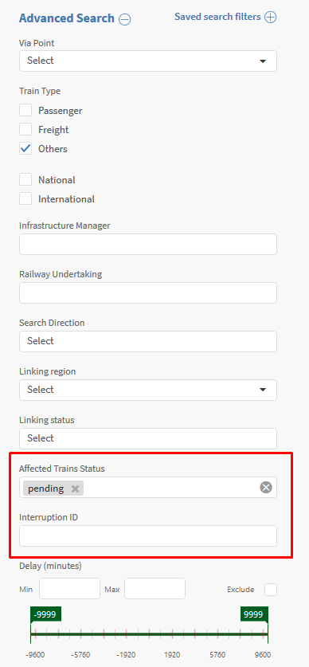
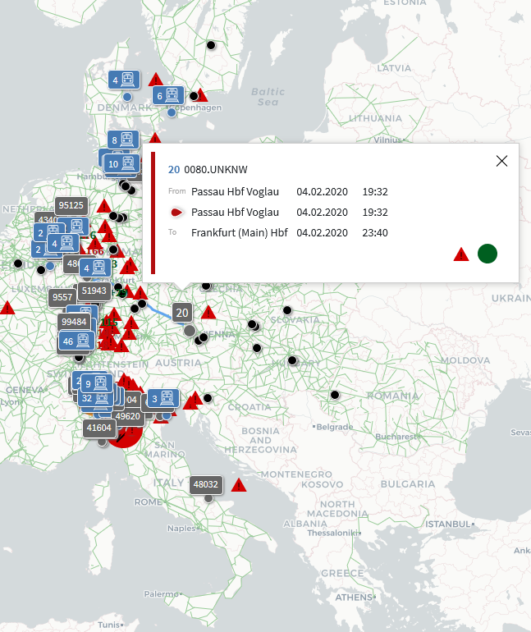

The similar functionality is also available in Space-time and Connection diagrams.

Train Info page

Special Incident information section is also available in Train Info page:
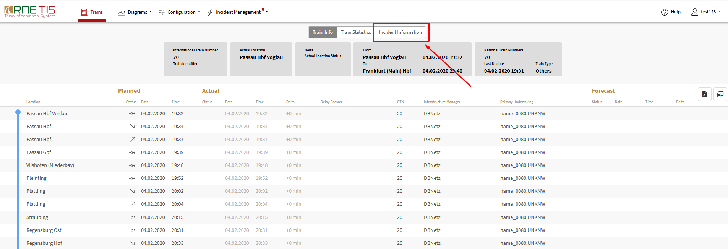

Within Incident information section, the following information are displayed:
- Header:
  - Date and time when train got affected + Interruption ID
  - (if train is affected by more interruptions, all of them are listed)
  - Location of Interruption (if entire network is relevant only IM is specified)
  - Scheduled at interrupted point (Planned Date & Time in Interrupted point
- History – the latest changes displayed on top
  - Time of change
  - IM ID – IM doing the change
  - Description of change (Status, Parking IM, Parking Location, Time of parking)
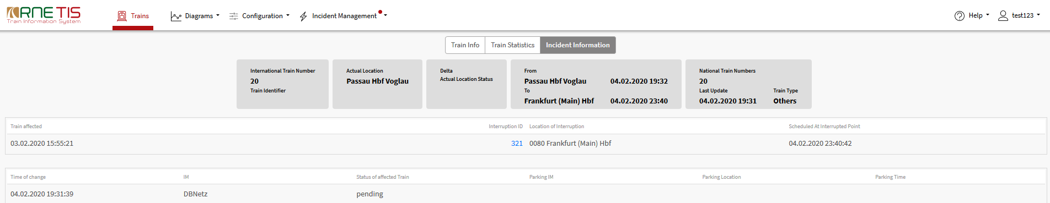
Information about Interrupted location is also visible within train information page:
