TCCCom functions in TIS 2020

RailNetEurope
Oelzeltgasse 3/9
AT-1030 Vienna
Phone: +43 1 907 62 72 00
mailbox@rne.eu
www.rne.eu

Contents
1. Introduction 3
2. Migration 4
2.1. Usage of TCCCom function 4
2.2. Scope of TCCCom migration 5
3. Train related information 6
3.1. Manual update of train information 7
3.2. E-mail notification tool 9
4. Event related information 10
4.1. Incident Management tool for TCCCom community 11

Introduction

With the planned introduction of new TIS 2020, as a successor of TIS system, all old TIS functions were evaluated and the optimised migration plan was agreed.

The purpose of this document is to explain to TCCCom community in detail how the migration from old TIS to TIS 2020 concerning the TCCCom functionality has been done and how to use the new TIS 2020 functions in case of need of communication between dispatching centers.

The information about the basic TIS 2020 functions can be found in TIS 2020 user manual here:
https://cms.rne.eu/system/files/tis_2020_user_manual_6.pdf or the video tutorial here: https://cms.rne.eu/tis/content/tis-videos-0.

To understand in detail all functions of the Incident management tool, mentioned later in this document, the specific Incident management functional handbook was developed and can be provided on request by Ivana Tomekova (ivana.tomekova@rne.eu).

Migration

Before deciding which TCCCom messages and functions will be migrated to TIS 2020, the evaluation of the current usage of TCCCom functionality was done.

Usage of TCCCom function

Based on the statistics of send TCCCom messages during years 2017, 2018 and 2019, the TCCCom messages to be migrated to new TIS 2020 were defined. As several TCCCom messages were never used during the monitored period, or are partially covered also by new Incident management tool in TIS 2020, they are not to be specifically integrated in the new TIS 2020.

TCCCom Message type | Number of send messages  (2017 – 2019) | Availability in TIS 2020
Train related messages
Train Delay | 1234 | TIS 2020 Train details
Train Cancellation | 11 | TIS 2020 Train details
Train Run Interrupted | 1 | Not to be migrated
Train Running in advance | 0 | TIS 2020 Train details
Train speed restriction | 0 | Not to be migrated
Re-routing of train | 9 | Not to be migrated
Change of train number | 1 | Not to be migrated
Request for actual info | 6 | TIS 2020 Train details
Event related messages
Advance notice | 1 | To be merged and integrated in TIS 2020 Incident management
Incident advice | 55
Direct communication needed | 5
System break down | 1

Scope of TCCCom migration

Considering the introduction of English-speaking dispatchers in each network traffic control center and implementation of TAF TSI messages in TIS 2020, the need for manually exchanged information about train runs should be decreased.

Therefore, the usage of TCCCom tool was evaluated and instead of one-to-one migration to the new TIS, the following adaptations were made:
- Train related information (especially train delays) are to be reported directly to TIS 2020 via automatic message exchange or manually via user interface (details to be found in chapter 3.1)
- Event related information (like Incident advice) are to be reported via new Incident management tool (details to be found in chapter 4)
- E-mail notification about train related information will be provided via new TIS 2020 E-mail notification tool (details to be found in chapter 3.2)
- E-mail notification function about event related information will be provided via new Incident management tool

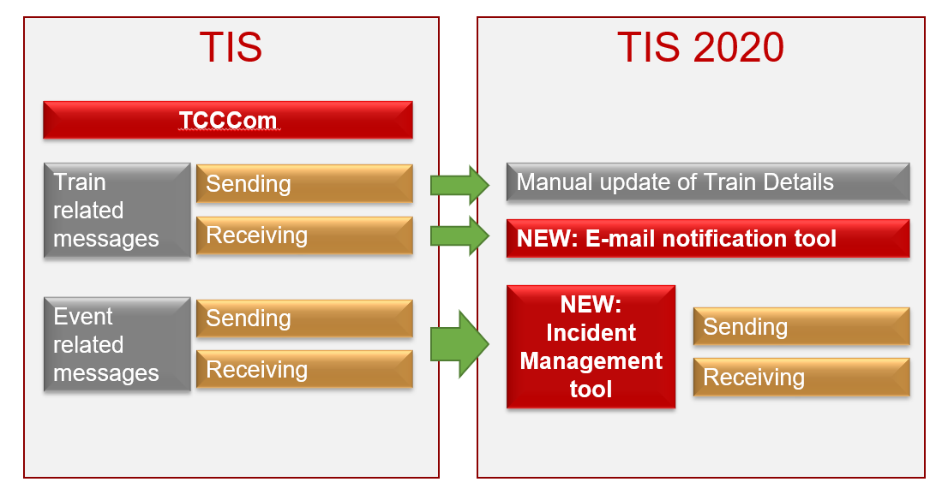

Train related information

The information exchange about train related information is completely covered by TAF/TAP TSI processes and messages. One of the main functions of TIS 2020 is the data exchange with IM legacy systems (both incoming and outgoing). All TAF/TAP train related messages received from one IM legacy system can be exchanged/forwarded to other IM legacy system. Therefore, the main goal should be to deliver correctly all train related information into TIS 2020 via relevant messages.

Moreover, TIS gives the possibility to every IM to integrate the information received from TIS to the national IM system, and thus display the relevant information for dispatchers in their domestic system, without the need to use the TIS 2020 user interface.

However, as not all IMs are yet ready to receive and process the data from TIS in their legacy system, there is still a need to exchange some of the train related information on the manual (human to human) basis.

Based on the statistics, the train related information which was most frequently exchanged between traffic control centers was the information about train delays. The TCCCom message about train delay was send only to the manually selected users and was not visible to all involved partners. With TIS 2020 the goal is to record all train relevant information directly in the system, so it is available to all involved partners. This can be done via manual update of train details, as described in chapter 3.1.

In the TCCCom tool, the dispatcher was informed via e-mail notification, if the updated information was sent to him. As majority of the dispatching centers are not using TIS or TIS 2020 online (as this would mean to add additional screen to their workplace), the e-mail notification function will be also developed in TIS 2020, as described in chapter 3.2.

Manual update of train information

In the specific situations, IM dispatcher can update manually the train details (timetable, delay, forecast) directly within TIS 2020. By using this function, the updated information is automatically recorder to TIS 2020 and available to all relevant partners.

To be able to update the train info, user must have a right: Edit own train details (given by the National TIS Admin).

User with this specific right, when opening the train details page, can edit the following information:
- Planned time
  - Status
  - Date
  - Time
- Actual time
  - Status
  - Date
  - Time
  - Delta
- Delay reason
- Railway Undertaking
- Forecast time
  - Status
  - Date
  - Time
  - Delta

To edit any of the above-mentioned information, user just click on the relevant box, which is then opened for editing and correct value can be entered.

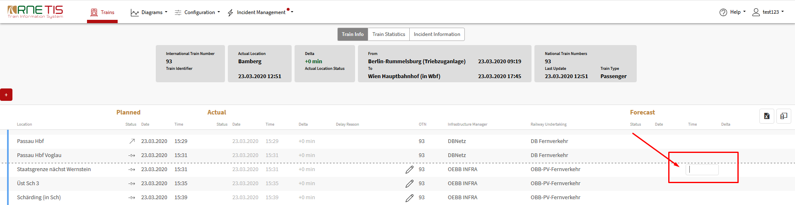

User has also the possibility to insert new line, in case a Point is missing in the current train details. This can be done by pressing PLUS button on the top or bottom of the page.

As first action, user should define the point (HINT: starting to write the few letters from location name will offer the drop-down menu listing available relevant TIS points). Then all other information can be entered as well.

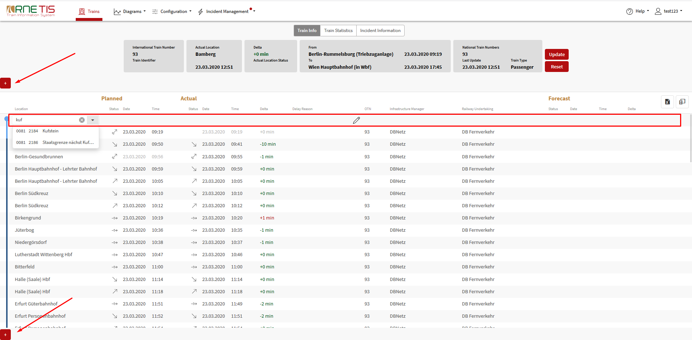

During the editing of the train details, the auto-refresh function of TIS 2020 is disabled. Once all information are given, user must press the UPDATE button and information is recorder to TIS 2020 and available to all TIS users.

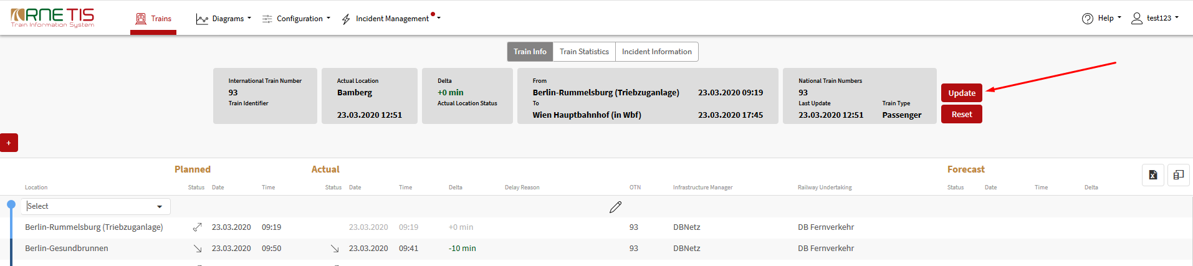

E-mail notification tool

As dispatchers are not using the TIS 2020 as a desktop application, the E-mail notification function will be developed, so they are warned about the situations they are interested in and in which they need to react.

This function will be user specific. Each user can define his own criteria for receiving the e-mail notification. Only users with specific e-mail notification right would have access to this.

New TAB in TIS 2020 main menu will be available: “Email notification”.

In this tool, user will be able to define the cases, for which notification will be sent to him (always related to single train):
- Type of information (to which info should notification be related?)
  - Delta t of train (threshold values - multiple), e.g. if certain delta t value is reached, user want to have notification
  - Forecast delta of train (threshold value), e.g. if certain forecasted delta t value is reached, user want to have notification
  - Train cancellation, e.g. if train cancellation message is sent for his relevant trains
  - Train affected, e.g. if his train got affected by interruption (POR) and every status change
- Trains relevant for notification - for which trains notification should be send
  - Train type – e.g. only freight international trains
  - User network – e.g. involved/(incoming/ outgoing)/all trains
  - Trains – e.g. only defined train numbers, or ranges
  - Points – e.g. only trains passing certain point
- When to send notification
  - Only first time the case occurs
  - Every time when case occurs
  - Only if case occur:
    - within Timeframe (before entering first user relevant point) – e.g. earliest 2 hours before first CTT time relevant for user
    - in certain point – e.g. if forecasted delta for border point is above threshold value

This tool is a new requirement in TIS 2020 and its development is not yet finalised. As soon as tool will be available, the detailed instructions how to use the tool will be provided.

Event related information

To share the information about the Incident, including the advance notice message, the new TIS 2020 Incident management tool should be used.

The primary goal of the Incident Management tool is to record the information about interruption into TIS 2020, so it is visible to all users. Depending on the status of the interruption, 2 different scenarios can occur:
- Scenario 1: Need to only share the information about interruption and its consequences
- Scenario 2: Need to agree also on the treatment of affected trains – trains to be parked

Scenario 1:
- Serve to only information exchange – previous TCCCom functionality
- Treatment of affected trains not to be communicated via TIS 2020
- Affected trains identified only for the notification purposes
- Interruption recorded by pressing “NOTIFY” button
Scenario 2:
- Used when there are some trains foreseen to be parked
- Communication about treatment of affected trains done via TIS 2020 – previous Park or Run functionality
- Affected trains identified and loaded to Overview of affected trains (3.4)
- Interruption recorded by pressing “PUBLISH” button
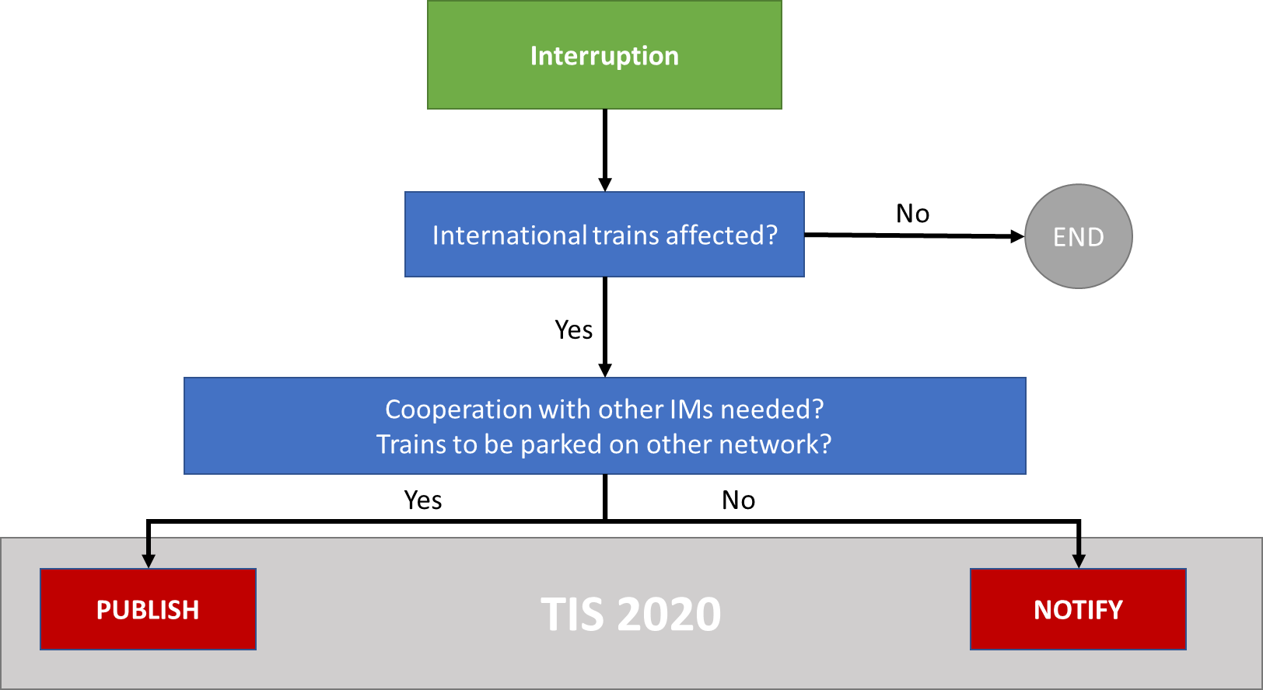
The TCCCom users, using the tool only for information purposes, follow only Scenario 1 instructions, as described in the Functional handbook of Incident Management tool.

Incident Management tool for TCCCom community

All the detailed information related to the Incident Management tool (e.g. user management and description of main functions) are provided in the Functional handbook Incident management in TIS 2020.

The TCCCom users are advised to study this handbook, especially focusing on the following, TCCCom relevant sections:

- 2 About Incident management tool
  - 2.2 User management
    - 2.2.1 User roles
    - 2.2.2 User rights
    - 2.2.3 User preferences
  - 2.3 Translation management
- 3 Main functions – functional specification of tool
  - 3.1 Define interruption
    - 3.1.1 Interruption definition page
    - 3.1.2 Preview function
    - 3.1.3 Finalisation of Interruption definition
      - 3.1.3.2 Notify Interruption
  - 3.2 Interruption message list
    - 3.2.1 E-mail notification about Interruption

All other chapters are more related to the usage of the tool by previous Park or Run users and not so relevant for previous TCCCom users.

