IT specification of the Capacity Model

Appendix to the RNE TTR IT Landscape specification

Version 0.7

RailNetEurope
Oelzeltgasse 3/9
AT-1030 Vienna
Phone: +43 1 907 62 72 00
mailbox@rne.eu
www.rne.eu

Version history

Version | Date | Changes | Responsible
0.1 | 2021-05-10 | Creation of the document structure. Alignment with the “TTR IT Landscape technical specification v1.0” and “Description of the Timetabling and Capacity Redesign Process” documents. | Mario Toma
0.2 | 2021-06-25 | Mistake correction, inclusion of the Excel data structure for importing data and mock-ups for the central implementation | Daniel Haltner  Sebastian Čarek  Máté Bak  Mario Toma
0.3 | 24.08.2021 | Import data structure (Excel) changed, traffic type codes defined | Máté Bak  Ivona Haban  Mario Toma
0.4 | 06.09.2021 | Document update according to the received feedback from the TTR IT Core Team group | TTR IT Core Team
0.5 | 28.10.2021 | Re-definition of the IT specification according to a new Capacity Model handbook definition (approved in October 2021) | Mario Toma
0.6 | 22.11.2021 | Re-shape a document according to the feedback received from the members and the Process group | Mario Toma
0.7 | 17.01.2021 | Correction of the document and inclusion of the received feedback. The document was presented to the DCM group and approved on 18.01.2022 | Mario Toma

Contents

Introduction 4
Definition of the terms 4
Capacity Model description 5
Technical aspect 6
Capacity Model rights in the tool 7
Capacity Model IT overview 8
Creation of TCRs 8
Import historical traffic usage data to define an intended capacity line (ICL) 9
Create/import/update/delete traffic capacity data 10
Create/Import CNAs 12
Decision on CNAs 13
Implementation of the Capacity Model 14
The full scope of implementation 14
Prerequisites for Capacity Model creation 14
Capacity Model data preparation 15
Traffic part 15
TCR part 16
Verification of the uploaded information 17
Modification of the uploaded data 18
Data import via Excel 19
Capacity Model visualization 20
Rules 20
Codes 21
Overviews of Capacity Model 22
Requirements 27
Annexes 28
Annex 1: Capacity Model – Requirements for the central side (ECMT) implementation 28
Annex 2: Capacity Needs Announcements – Requirements for the central side (ECMT) implementation 31
Annex 3: Capacity Model import template 37
Annex 4: Excel data structure for the Capacity Model import (including samples and description) 37
Annex 5: Excel data structure for inclusion of the intended capacity usage line 37
Annex 6: Excel and XML template structure for importing the TCRs, including the TCR message description and schema 37

Introduction

This document aims to provide a detailed overview of IT requirements to handle the Capacity Model and Capacity Needs Announcements data and visualize them in the ECMT.
This document will cover the necessary implementation, on both, the central and national sides.

The document will not cover the Capacity Strategy or the Capacity Supply topics.

The basis for this document creation is the following documents:
- Description of the Timetabling and Capacity Redesign Process,
- TTR IT Landscape Technical specification,
- Procedures for Capacity Model,
- Procedures for Temporary Capacity Restriction Management.

Definition of the terms

This document uses many terms that are already known within the TTR Process and TTR IT Landscape projects, but still, it is worth mentioning some of them again for those users who are not yet familiar with these terms.

Term | Explanation
Advanced planning | Set of processes in TTR that covers the Capacity Strategy, Capacity Model and Capacity Supply phases
ECMT | European Capacity Management Tool – initially developed to support TTR Pilots in capacity visualisation. The tool will cover the Capacity Hub module functionalities. The tool shall be used to support the Capacity Model and Capacity Needs Announcements creation. ECMT is also the Capacity Supply tool.
TCR Tool | The central tool used for TCR creation and coordination. The tool shall be used by IMs and Applicants to visualize all TCRs and their statuses
Capacity Strategy | The defined Capacity Strategy is a document describing the main principles of capacity planning including all types of capacity needs.
Capacity Supply | The Capacity Supply is a 365-days overview – capacity diagram, where objects as pre-planned paths, bandwidths, TCRs and empty spaces for tailor-made requests and already allocated capacity products are displayed. The supply is published by one or more IM(s) from X-11 onwards.
CRD | Central Reference File Database, formerly known as Central Repository Domain, is a common repository node in the network containing the reference files
CM | Capacity Model presents information on the traffic volumes and shares for TCRs
CNA | Capacity Needs Announcement presents information and first idea on the future traffic from Applicant
PLC | Primary Location Code as defined by TAF TSI standard
TTPs | Timetable periods
X-# | A deadline referring to the Annual Timetable change (X) and the number of months (#) in advance of this deadline.
PSO | Public service obligation – related to the transport or traffic flow
TIS | Train Information System – RNE web-based system that provides the real-time train traffic data and shows a real-time visualization of the international trains
ICL | Intended Capacity Line
Dijkstra algorithm | An algorithm for finding the shortest paths between nodes in a graph which represent a network. For a given source node in the graph, the algorithm finds the shortest path between that node and every other.

Capacity Model description

The focus of the Capacity Model is on the traffic volumes and TCR duration. The aim is to show, harmonise and discuss more in detail the expected volume of capacity consumed by each market segment (commercial needs), currently known as TCRs and TCR windows.
The capacity model sets the volumes of the transport per each market segment and the capacity consumed by TCRs on a specific line specified per direction. It does not define exact paths or TCR details (such information will be provided in the Capacity Supply).

The Capacity Model consists of two parts:
- 24-hour overview (per direction) reflecting market needs (Traffic part)
- Overview of the capacity consumed by TCRs (TCR part)

From a geographical point of view, the capacity model shall be prepared for the complete network with the exception of regional lines/feeders/outflows with a single applicant.
The model/partitioning is done for each direction on the network sections, which is defined by each IM. These sections on the network can be combined in the tool, to display an overview for complete lines, corridors or networks.

Technical aspect

The main modules that are considered in the Capacity Model management are Capacity Hub and TCR modules. These modules shall be supported by RNE’s systems: ECMT and TCR Tool.

The relevant TTR IT Landscape modules that shall be used in the CM are the following:
- TCR (TCR Tool) – to manage the coordination and inclusion of TCRs. The TCRs from the TCR Tool shall be used for the calculation and fulfilment of the TCR duration for the CM,
- Capacity Hub (ECMT) – to collect and display data on capacity volumes including CNAs and TCR duration overview from the TCR Tool.
- BigData – is a central repository for all infrastructure data, that will be used in the Capacity Hub (ECMT) for synchronization of all necessary infrastructure data needed for visualisation of CMs on the IMs’ network,
- Messaging module - to connect all modules, and to establish a connection for data exchange between national (legacy) systems and central systems based on TAF/TAP TSI,
- Capacity Needs Announcements (CNA) – to provide information on future capacity needs. The CNA function in the ECMT will support the Applicants needs to express (create/import) their first information on future traffic needs.

The diagram below shows the context of the CM aspect and the high-level communication including data exchange between the modules involved in the model creation.

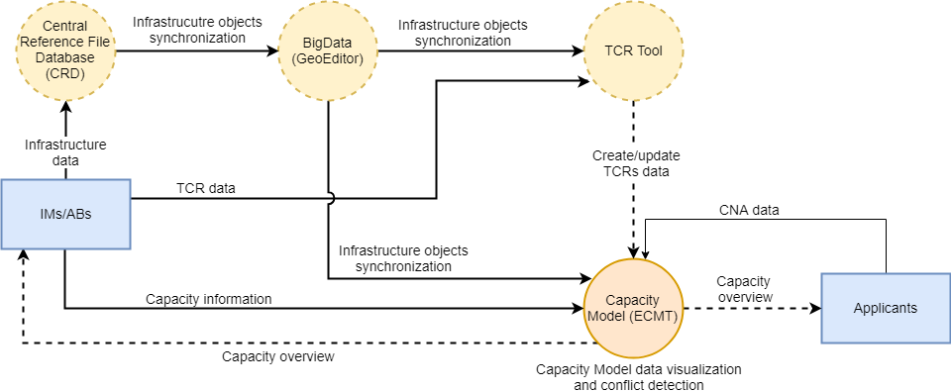
Figure 1 - Context diagram of the Capacity Model

Infrastructure data
IMs will update their infrastructure data on regular basis (when there is an update), in the Central Reference File Database (CRD), as they do today.
It is important to highlight that infrastructure data will be entered once and then reused from other RNE systems.
Infrastructure data, provided in the CRD, is synchronized with the RNE BigData database, which serves as the source database for all modules defined in the TTR IT Landscape.
The necessary infrastructure data needed for the CM is related to the background topology data which includes the locations (PLCs) and segments object, but also to the ECMT layer on which the sections are defined.

TCRs
IMs import TCRs from their national systems into the central TCR Tool, where all TCRs are visualized to all IMs and Applicants after their publication deadline. TCRs with international impact are firstly coordinated among involved IMs and then published to be visible to the Applicants and all interested parties.

The TCR Tool shall be used to provide information about the TCR duration for the referenced year for the ECMT. Duration about TCRs will be provided from the TCR Tool.

Capacity Model
Capacity Model contains four main groups of data:
- Intended Capacity Line (ICL) data – that considers historical capacity usage data that can be imported from the TIS, or the national traffic management system, or can be manually defined by IM
- Traffic volumes data – capacity data provided from the IM national traffic management system, or manually defined by IM
- CNAs data – capacity needs data provided from the Applicant’s system or by using the Excel structure for CNA import, or manually defined by Applicant
- TCR data – imported by IMs to the TCR Tool shall be synchronized with the ECMT

More information about feeding the CM is provided in the “Capacity Model IT overview” topic in the text below.

Capacity Model rights in the tool

Access rights to the CM function of the ECMT are the following:
Roles | Rights in the tool
IM role | All IMs have the rights to the CM for the referenced TTP, after the start phase.  These rights concern the following:  - Creation and modification traffic volumes for the CM (incl. variants)  - Coordination of CMs with neighbours for the border crossing  - Acceptance and consultation of CNAs  - CM publication (draft and final version)  - See all CMs and the network
Involved Applicant’s role | Involved Applicants rights for the respective TTP:  - Creation, modification and submission of their respective CNAs for the referenced TTP  - Acceptance/consultation on IM’s proposal related to the CNAs that do not fit the CM  - Access to the published draft version of the CM
All Applicants role | All Applicants have the right to see the final version of the published CM

In the sense of confidentiality, only IM will work on their draft version of the CM and will have a right to visualize and update them before the publication.

Capacity Model IT overview

Considering CM data creation and timeline, the following sequence diagram provides activity and functions, taking into account all involved parties (Applicants, IMs/ABs).

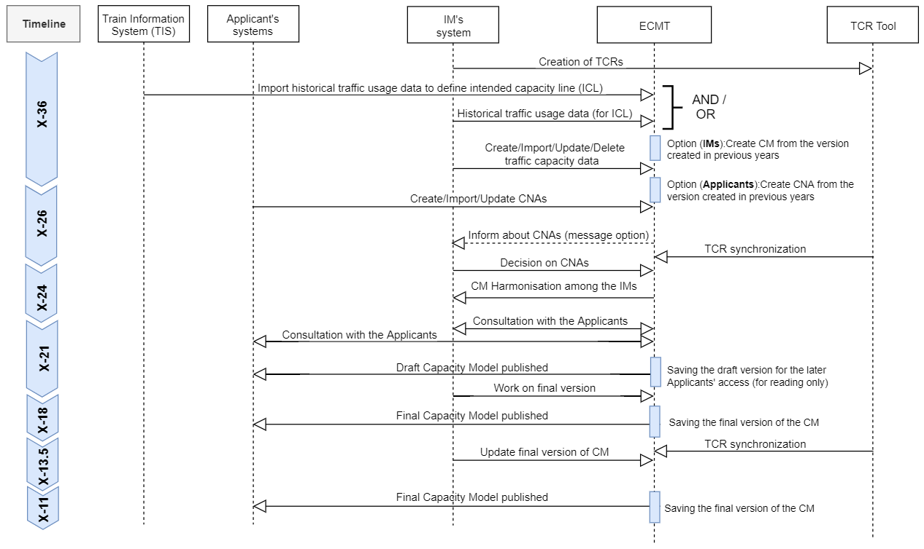
Figure 2 - Data creation sequence diagram

In general, the creation of the CM can be divided into a couple of steps, which are illustrated in the above image and cover the creation of the traffic part of the CM.

Each step will be explained in topics below, including the necessary implementation on the central and national side.

NOTE: The content of the processes between X-18 and X-11 could be updated or changed, while they are still discussing at the Process group.

Creation of TCRs

The first information to be delivered to the central systems is the information about the known major and high impact TCRs. IMs will create/import all known major and high impact TCRs by using the TCR Tool only. They can start doing this by starting from X-36.
IMs shall prepare their planned TCRs in one of the data exchanges formats (Excel or XML) and import data into the TCR Tool. IMs that implemented the technical interface (API) shall use the TCRMessage to exchange data among the systems. By using the technical interface, IMs have the possibility to update TCR data whenever they have new information, directly from their national tools.
Information about the created TCRs shall be synchronized with the ECMT. This means, that the same data that exist in the TCR Tool will exist in the ECMT as well. For this purpose, the TCRMessage shall be used to “push” TCRs from TCR Tool to ECMT.
TCRs in the ECMT will be used for the visualization purposes and calculation of their impact on planned traffic flow.
All functionality of TCR creation, harmonization and publication will be done in the TCR Tool.
After TCRs are imported into the TCR Tool, the TCRs with the international impact must be coordinated among involved IMs. Affected IMs are automatically involved in the TCR coordination, and they can do the coordination by checking the TCRs in the TCR Tool and combining them on one of the existing views in the tool.
All updated information (TCRs) will be sent from the TCR Tool to the ECMT.
TCRs can be updated in the TCR Tool until X-24, when all TCRs with the international impact that are coordinated, must be published.

The latest Excel and XML template structures for importing the TCRs are provided in Annex 6 to this document. In addition, as a part of Annex 6, the TCRMessage schema and element description is provided.

Import historical traffic usage data to define an intended capacity line (ICL)

The ICL indicates the maximum number of trains that can be accommodated without paying special attention to capacity planning / extraordinary traffic management measures. The first data import that could be done directly to the CM of the ECMT, is information related to the intended capacity usage line data. This creation can start after the CM is open for data creation/import, after start (X-36).

The aim of the calculation of the intended capacity line on one hand is to provide a clear picture of the planned capacity situation and to detect the pressuring points, where the IMs have to make additional efforts to ensure the stability of the timetable. On the other hand, the IMs and applicants will have a clear picture of the number of unplanned capacities, which would be available for the ad hoc requests during the concerned timetable period.

The ICL data should be created for the railway line. The railway lines for the CM will be defined in the BigData and synchronized with the ECMT by using the database synonymous. The lines from the BigData will be synchronized with the ECMT and presented on different views. Considering the lines and visualizing them on a route that can contain one or more lines, the ICLs created for the railway’s lines shall be combined. This means that in case the route contains two lines, one from A to B and the other from B to C, the ICLs defined for this route shall be combined and both presented as one ICL from A to C.

For implementation for the TT2025, RNE considers a possibility to fill in ICL data for line by using the historical data from TIS (Train Information System) for each country, to support IMs with this first data creation. Also, this data can be updated considering the historical data from the national traffic management tools, to build a complete and more precise ICL. To guarantee the stability of a timetable, an IM can selectively raise the ICL data at certain hours (e.g., rush hour).

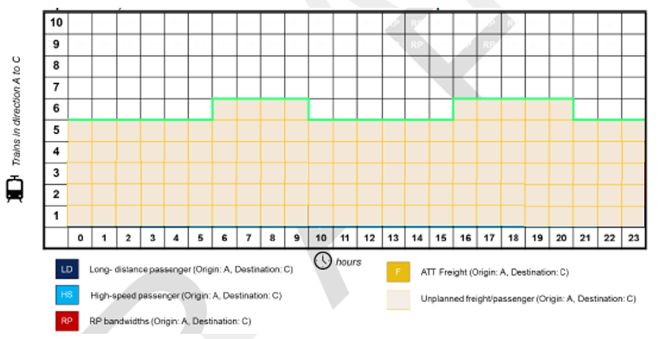
Figure 3 - Intended capacity line visualization on the Capacity Model section view

This ICL data should contain information about the number of trains for each hour in the 24-hour overview (Section view) and be related to every line of the network.

The Excel structure for data import is provided in Annex 5.

Data for ICL can be provided for one non-TCR day and will be used for the whole period of validity of the CM (up to 365 days). For this purpose, the calendar for the CM shall be implemented in the ECMT. The IM shall set the ICL value for each hour in 24-hour and define the period and line to which these values shall be applied. This information shall be saved in the database, considering one record for each day defined inside the validity period of ICL.

Create/import/update/delete traffic capacity data

The most important step is to make plans about how the infrastructure will be used in the future. These plans IMs can do this on their own or in consultation with Applicants. On international lines, harmonisation with involved IM(s) is essential. This includes studies about routings and frequencies of national and international connections on the network.

A CM creation itself starts with uploading the time data of the volumes into the ECMT on the PLC level for each line. The input in the Excel structure should contain at least two values for the line. This means that data for the origin point (PLC) and destination point of the line should be entered. Also, the records for the intermediate points (between origin and destination) can be entered.

In the case that not all data for CM is provided in excel, considering all intermediate segments, then the ECMT takes into account time data that is defined on the origin (or previous) location and generate the volumes on the intermediate segments, considering the distances between locations and planned speed parameter up to the destination.
For instance, let’s consider that the origin location, mentioned in the Excel import, is “Wien Hbf” and the destination is the “Budapest-Keleti” location. Only these two records are defined with the same ID, which means that belongs to the same CM. During data import, the tool will calculate the shortest route, based on the Dijkstra algorithm, and would fill in the missing PLCs. These intermediate locations are added to the route, considering the initial data provided in the Excel, and to provide capacity information for each segment on the route.
An example is provided on the image below:

Example

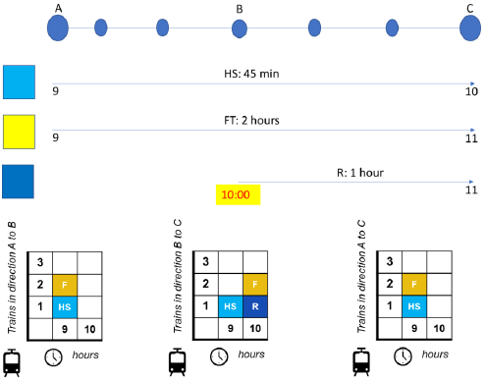  Figure 4 - Example of traffic volumes on the A-C network section | Explanation:  - The railway line between A – C (via B)  - Direction A → C  - Additional points can be added (based on PLCs)  - High-speed passenger train travel time from A to C: 45 min  - ATT Freight train travel time from A to C: 120 min  - Regional passenger train travel time from B to C: 60 min

If the request considers visualization of data for the whole line from A to C, for which data is provided, then the ECMT will not generate the information for point B on the line. This information will be generated in the case that the request considers visualization of data from A to B or B to C on the same line (line A to C), then ECMT will generate information about the time for point B.
The Capacity Model visualizes the values, which are valid at the first planning point (PLC). In case the model is generated for the volumes from point A to C, then it takes into account the time data, which is available at point A. Therefore, the volumes from point B towards point C will not be considered during the generation of the Capacity Model between points A and C.

Figure 5 - Example of Excel data import for A-C

The template for traffic part data import is provided in Annex 3 of this document, and IMs shall use it to define their estimation for the traffic needs.

In addition, to providing data for the traffic part of CM using the Excel template, the CM can be generated directly in the ECMT from one of the previous CMs that already exist in the ECMT or by manually filling out the ECMT form.

For the CM creation from the previous CMs, IMs will have a possibility to search the old CMs and select data to be carried forward to a new CM. Such data can be further modified in the tool regarding the IM’s traffic estimation and then saved to the new created CM. This functionality will not be available for CM creation for the TT2025, while CM data will be created for the first time.

CM data is visualised on the graph as presented in figure 6.

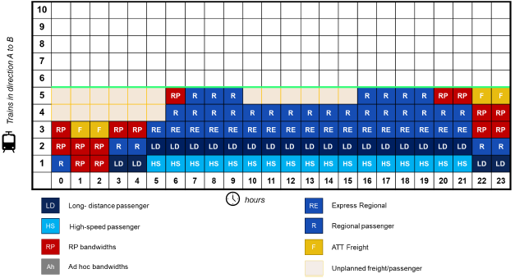
Figure 6 - Example of the 24-hour traffic part of the Capacity Model section view

During the preparation of the CM, not all capacities have been filled with volumes, therefore, unplanned capacities remained for later utilisation (as presented on the graph below the green line with orange colour).

Considering the cross-border lines or section (part of the line), data about the volumes must be aligned among the IMs, and IM defined in the Capacity Strategy as a coordinating IM should coordinate the creation of the draft/final CM.

Create/Import CNAs

Applicants start to import their capacity needs in the ECMT at X-26. For this purpose, the Excel file template is created and shall be used for the TT2025. The structure for data import is provided in Annex 7. By using the same template, Applicants can update CNA data.

In addition, the CNA form in the ECMT can be used for the manual creation of CNA data.

For the later years, after the first CNA is created in the ECMT, Applicants will have a possibility to search and carry forward data from previous CNAs. Description of the requirements and their implementation on the central side is provided in Annex 2.

All created and/or imported CNAs data after submission from Applicant is collected in the “Waiting room”. The “Wating room” presents a table in the database where CNAs data waits for IMs to do their analysis and decision about the inclusion of CNAs data into CM.

Decision on CNAs

After submitting the CNAs after X-24, IMs will start with the inclusion of CNAs into the CM. This means that IMs will start with the analysis of CNAs in the tool, with the support of the automatic compare and visualization functions in the tool that will easier this task.

The tool should have a function to automatically compare CNAs that correspond to the volumes defined in the CM. For this purpose, a summary of all CNAs related to the same CM and section will be presented in parallel with CM volumes defined by IM on the other side.

These CNAs and volumes that fit shall be marked and IM will have possibility to approve or reject their inclusion (merge CNAs) in the CMs. With this functionality IMs will involve CNAs marked by the tool or manually by the IM, into the current CM. On this way, CNAs data will be transferred from the “waiting room” into the CM database.
Information about CNA acceptance or rejection will be automatically provided to the responsible Applicants (who created them).
In the case of the rejection, the reason must be mentioned, and the CAN shall be eliminated from the “waiting room”.

IM will check the remaining CNAs and mark them for one of the following actions:
- Approval
- Rejection
- To be updated

Approval
Those CNAs that IM sees that can still fit the CM will be manually selected and approved. After this approval, they will be transferred from the “waiting room” to the CM database, about which an automatic notification to all involved Applicants will be sent.

Rejection
Those CNAs that cannot fit the CM according to the IM’s capacity possibilities, shall be marked for rejection together with the reasons for this decision. These CNAs will be eliminated from the “waiting room” and automatic notification to all involved Applicants about the rejection shall be sent together with the reason.

To be updated
Those CNAs that needs some modification to fit the CM according to the IM estimation, will be marked for update (“to be updated”) together with the reasons for requesting an update. IMs will provide information about the reason for requesting an update, and the status for these CNAs will be set to “to be updated”. Information about status and CNAs shall be sent to the involved Applicants. Involved Applicants will check the possibility of whether the CNAs can be modified in line with the IM’s feedback.
If yes, Applicant shall modify CNA according to the IM request, and if not the CNA will be withdrawn from the “Waiting room”.

In addition to asking the modification of CNAs to fit the CM, IMs can propose an alternative solution, like different route, different times, days of the weeks, etc. The status of such CNAs shall be set to “Alternative consideration”, and the list of CNAs with this status shall be sent to the involved Applicants. The Applicants should check alternatives and answered with one of the three possible answers: Accepted, Rejected or Not suitable.
In the case of acceptance, the stored CAN data shall be transferred from the “waiting room” to the CM table in the database to complete CNA dossier with all relevant information.
In the case of rejection, the CNA will be eliminated from the “waiting room”.
In the case that provided alternative is not suitable, the reason about this will be provided to the IM, and IM shall check CNA again together with provided reason of not suitable alternative and make decision.

If there are unplanned capacities that remained after CMs have been filled in, these slots can be used for later capacity needs.

Implementation of the Capacity Model

The full scope of implementation

The full scope implementation implies the full IT implementation and data exchange via TAF/TAP TSI based interfaces that will be defined and common forms in an automatic (technical) way.

Applicants

Applicants should be able to submit their data via common forms and a common portal in a standardised format (standardized interfaces).

Infrastructure Managers (IMs)

IMs can receive input and exchange data between their national and international (central) systems. All the inconsistencies are possible to detect and communicate technically.
Data should be automatically exchanged with central ECMT, by defined messages.

Applicants should be consulted about the results via Capacity Hub (ECMT) for all sections on the network.

Prerequisites for Capacity Model creation

Before the start of the CM phase, some prerequisites for the ECMT must be considered and filled in. These prerequisites are the following:
- Geography from the BigData database is synchronized with the ECMT
- The validity periods of the PLCs are considered in the CM (a new created PLCs which are valid for the referenced TTP are shown, and those which validity expired are not shown)
- Historical data about the number of trains from TIS or national traffic management systems are prepared for the import
- TCRs with the major, high impact on traffic are created/imported in the TCR Tool by IM and, these with the international impact, coordinated with the neighbouring IMs

Capacity Model data preparation

Traffic part

To prepare the Capacity Model data, IMs will take into account information provided in the Capacity Strategy document for the referenced year. Information provided in the Capacity Strategy is related to the two main blocks:

Expected capacity | Description
TCRs | Describes the principles for capacity allocation for regular TCR windows and the planning of TCRs
Traffic flow | Describes main principles to be used in the planning of elements in the Capacity Models

Information provided in the Capacity Strategy is a precondition for the development of a Capacity Model for a line, part of the line or the entire network. This information is considered in the creation, with further details related to the expected traffic and demands from the applicants (provided via CNA standardised form) that should be used for the Capacity Model. The “Capacity model data” provides an overview of the objects and attributes of these further details.

CNA shall be imported and will provide information on the future traffic needs that is expected, according to the requests or announcements already received from the RUs/Applicants, and also, including an estimation of the future needs considering the market growth.
The system should allow them to enter all necessary information and parameters for IMs to plan capacity. The entire process will be managed under the control and responsibility of the IMs, preserving full confidentiality.

A capacity needs announcement provided by Applicants will be a significant supporting factor in the commercial capacity need estimation.
The RUs/Applicants are invited to provide an indication of their future needs for capacity in a standardized way and participate in the design of the future capacity model.

The volumes for the annual timetable traffic could be estimated by taking into account information from this national traffic management system related to the past traffic (the volumes of the train services provided in the previous year), passenger trains operating regularly and dominantly having PSO contracts, freight trains operating primarily in a supply-driven way where the needed path details usually are known well ahead of time and regular freight trains with a contract with the customer for a short period (< 1 year) where the needed path details are known well ahead of time.

The volumes for the ad hoc/rolling planning traffic could be estimated from traffic management data from the past (e.g., national traffic management system), considering the irregularly running passenger trains (charter trains, holiday/seasonal trains, additional trains for events, etc.), freight trains that only run on one or a few days and where no preconstructed rolling planning capacity is available, all other trains for which no capacities have been preconstructed.

The Capacity Model data will be exchanged with the ECMT from IMs’ national tools via interfaces, except for the TT2025 where an intermediate solution shall be used. The intermediate solution refers to the use of Excel structure for Capacity Model data, which are exported from national tools, and imported into ECMT.

The recommendation is to calculate expected volumes at the level of details of a standard non-TCR day (a day in a middle of a normal week), for harmonisation at the international level and which is also the minimum requirement for TTR implementation. IMs can also construct more variants of the Capacity Model for the same train path line section for a specific season and or period of a particular TCR.

IMs can construct and publish more variants of the traffic part for a particular TT period:
- Standard non-TCR working day (at least one variant mandatory)
- Particular TCR period overview of the traffic flows during a specific TCR (mandatory for Major and High impact TCRs)
- The standard day of a special period such as summer/winter holidays (optional)

TCR part

The main aim of the TCR part of the model is to transparently announce and communicate to stakeholders the estimated capacity to be consumed by TCRs (based on the available information on TCRs) and an overview of capacity volumes that will IMs need to do the infrastructure maintenance.

The TCRs will be exchanged with the ECMT from the TCR Tool. There is no needed additional work on the IM side

For the TT2025, data for the CM regarding the TCRs will be exported from the TCR Tool database to the Excel structure and imported into the ECMT. This data should contain all TCR attributes.

For the later TTPs, this data will be exchanged among TCR Tool and ECMT via messages.

Considering the traffic data of the CM for the selected section (line) and defined calendar, the visualisation of TCRs should be provided as presented:
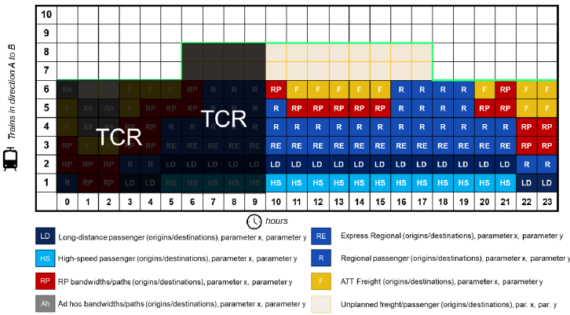
Figure 7 - Visualization of TCRs and impact on the traffic in the section view
This visualization is provided if both, the traffic and TCR part checkboxes are selected.

TCR duration overview

The duration of TCRs on the selected section (line) in the ECMT, will be presented in the following way, considering 365 days during the TT period.

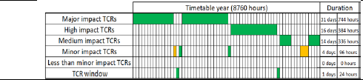
Figure 8 - Visualization of TCR duration

This kind of visualization is presented in the case that only the TCR checkbox on the CM is selected.

Verification of the uploaded information

Verification of the uploaded data must be supported by the ECMT. This verification check covers several aspects:

Check before/during data import
Imported data is firstly checked in terms of its validation in sense of data consistency. This validation check concerns syntax and semantic correctness:
- Syntax check – all columns of the Excel file are checked to comply with the allowed type values (e.g., identify if a numeric field contains other characters than [0-9])
- Semantic check - all columns of the Excel file are checked to comply with the constraints (e.g., PLCs or other defined types (like partition, category, train) are valid concerning the database, mandatory fields are filled in or not, and so on)

Check after data import
The data correctness of the uploaded information should be verified in the ECMT. For this purpose, ECMT will be able to generate overviews on the network section based on data, which was uploaded by the IMs regarding the concerned PLCs, as presented in the figures below.

The visualization overview must include a direction filter without exception whether it is a section with single or multiple tracks.

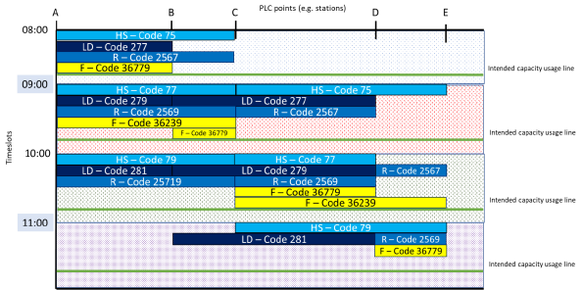
Figure 9 - Overview of the uploaded information in sense of data verification

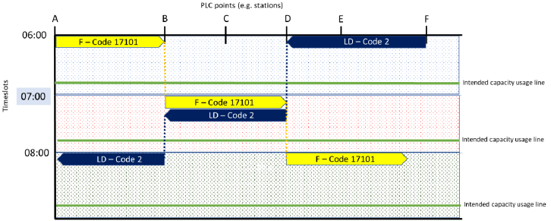
Figure 10 - Overview of the uploaded information in sense of data verification (single track line)

Modification of the uploaded data

The ECMT shall support the smooth modification of the previously uploaded information possibly with easy-to-use solutions:

- By selecting the section object on the network (map overview), the list with records of MC variants opens
- After clicking the Variant, the table with records of the selected object is opened, with visualization of this data

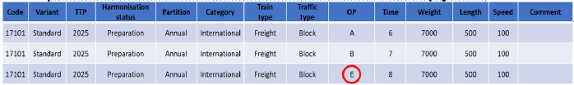
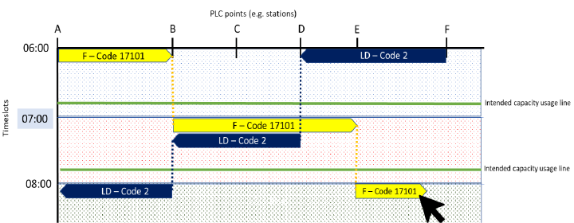

- By modifying data in the table, the visualization shall be aligned to the new data automatically
- After “Save”, made modifications shall be stored in the database

Data import via Excel

The Excel data structure that will be used for data import is provided in the Annex 3 of this document, including sample and explanation files provided in the Annex 4. The same data structure shall be used for the export functionality, to easier possible data modification.
The columns in the Excel sheets must be used as defined below in the tables. The first sheet is related to the traffic part and shall contain traffic information on passenger and freight trains including the regular maintenance windows. The second sheet is related to the TCR part and shall contain information about the TCR shares.
Traffic data (Annex 3)
- Column – meaning of the column in the Excel file (form the header row)
- Allowed type – the type of the column
- Constraints / Values – Rules that will be validated during the import and predefined values in Excel. Mandatory fields are marked with Not null.

Column | Allowed type | Constraints / Values
ID | Number | -; ID that combines all OP related volumes defined on the same train path line section
Code | Text | Not null; Train number, or any kind of unique identification of the object
Variant | Text | Not null; Value defines the unique key for the Capacity Model. All rows that belong to the same Capacity Model will be defined with the same Variant name.
TTP | Number | Not null; Referenced timetable year
Title | Text | Not null; Value must be one of the traffic types codes (defined above in this chapter) for which data is provided.
Harmonization status | Text | Not null; Value must be in [Preparation, Published, Closed]. By default, the preparation status is set.  Meaning of the statuses:  - Preparation – the draft version of CM  - Published – finalized and published version of CM  - Closed – close the object which means that t is not visible anymore in the model
Partition | Text | Not null; Value must be in [Annual, Ad-hoc, Rolling planning, TCR]
Category | Text | -; Value must be in [National, International]. By default, National is defined
Train type | Text | Not null; Value must be in [Passenger, Freight]
Traffic type | Text | Not null; Value must be in [High-speed train, Long distance train, Express regional train, Regional train, Domestic train, International train, Wagonload train, Block train, Combined transport train]
Operation point (OP) | Text | Not null; Defines the start point of the train path line section for which the Capacity Model is provided. By mentioning the origin information means that the model is created for direction from origin to destination. To provide information for both directions, two records for the same train path line section shall be created (with different OP values). Any intermediate point can be defined.
Time | Time | Not null; Time at which the traffic type is planned
Weight | Number | Not null; Gives information on maximum train weight
Length | Number | Not null; Gives information on maximum train length
Planned speed | Number | Not null; Gives information on the planned speed of the train
Comment | Text | -;

Capacity Model visualization

Considering the CM data visualization, it should be possible to present separately the traffic part, TCR part and then both combined.
For this purpose, in the form should be defined two checkboxes:
- Traffic part
- TCR part

The visualization of data itself should consider some roles and codes.

Rules

The traffic part of the Capacity Model diagram shall be presented in the tool by following some rules:
- Fulfilment of the chart starts from bottom to up for each hour in the 24-hour overview
- Fulfilment starts with the passenger trains first, then follows the freight trains and finally TCR windows
- The basic categories for passenger trains shall be entered in the order as follows
  - High-speed train
  - Long-distance train
  - Express regional train
  - Regional train
- The basic categories for freight trains shall be entered in the following order
  - Wagonload train
  - Block train
  - Combined transport train (optional)
- In the case that one of the train types for a particular hour is not planned, the next type of train in the order shall be presented (e.g., if the high-speed, long-distance and express regional trains are not defined, then as a first train for a particular hour will be a regional train, presented at a very bottom of the particular hour).

Codes

To simplify the presentation of traffic type volumes and capacity partitioning, the codes are defined as follows:

Traffic object codes
  - HS = High-speed train
  - LD = Long-distance train
  - RE = Express regional train
  - R = Regional train
  - DF = Wagonload train
  - IF = Block train
  - CF = Combined transport train
  - TW = TCR window

Capacity partitioning codes
- RP = Rolling planning
- Ah = Ad hoc
- AT = Annual timetable
- TC = TCRs

For each of the traffic object codes, a predefined colour in the tool shall be used. Using the colour to present a specific traffic object type will easier to read a diagram and will uniform data presentation in the Capacity Model. Colours will be set automatically by the tool, depending on the defined traffic type.
There is also a need to distinguish domestic and international traffic type volumes. Both (domestic and international) shall be presented with the same codes and colours, but domestic in addition will be presented with diagonal stripes.

The Capacity partitioning is presented in a way that traffic object volumes squares are presented with solid (2px) frame and pre-defined colours (the colours of the frame will be automatically set by the tool, depending on the selected partitioning).

The table below shows some of the possible combinations for presenting the traffic volumes (with squares/rectangles) in a diagram:

Code | Domestic / International | Train type | Partition | Colour presentation (proposal)
HS | International | Passenger |  | Light blue
HS | Domestic | Passenger |  | Light blue with diagonal stripes
HS | International | Passenger | ATT | Light blue with green frame
HS | International | Passenger | RP | Light blue with dark red frame
HS | Domestic | Passenger | ATT | Light blue with diagonal stripes and green frame
HS | Domestic | Passenger | RP | Light blue with diagonal stripes and dark red frame
LD | International | Passenger |  | Dark blue
LD | Domestic |  |  | Dark blue with diagonal stripes
RE | International | Passenger |  | Blue
R | International | Passenger |  | Brown
DF | International | Freight |  | Yellow
DF | Domestic | Freight |  | Yellow with diagonal stripes
DF | Domestic | Freight | RP | Yellow with diagonal stripes and dark red frame
RP |  |  | RP | Dark red frame
Ah |  |  | Ad hoc | Grey frame
AT |  |  | ATT | Green frame
TC |  |  | TCR | Black frame
TW |  |  | TCR | Black

NOTE: Not all the possible combinations were presented in the table. The table provides the general overview of how the visualization in the diagram will be made

Overviews of Capacity Model

The CMs in the ECMT can be visualised in three different formats:

- Network overview
The high-level overview of the CM considers the capacity situation on the network level on a daily or hourly basis using the intended capacity usage line. The Network is overview is important for the identification of capacity bottlenecks on a broader scale.
The network overview should be generated by the ECMT based on the provided information by the IMs.
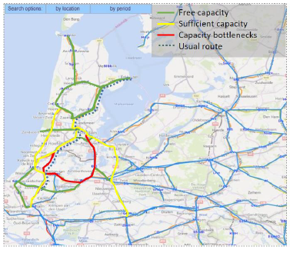
Figure 11 - Network overview of the Capacity Model

This visualisation provides better capacity visualization from IM and Applicant point of view. The IMs can see the bottlenecks on the network and take the necessary actions.
On the other side, Applicants can in an early stage see the congested lines and better plan their traffic and consultation with IMs.

To present the sections on the network with colours, the percentage between the occupied (planed volumes) and remained (unplanned) capacity considering the intended capacity usage line, shall be used in the calculation.

The percentages and the calculation methodology will be provided in 2022.

- Line overview – occupation diagram

After clicking the particular section shown on the network overview, the planned volumes summary for the selected section will be presented. It can be used for the verification of the IMs` inputs, and also for cross-border harmonisation and TCR-consultation purposes.
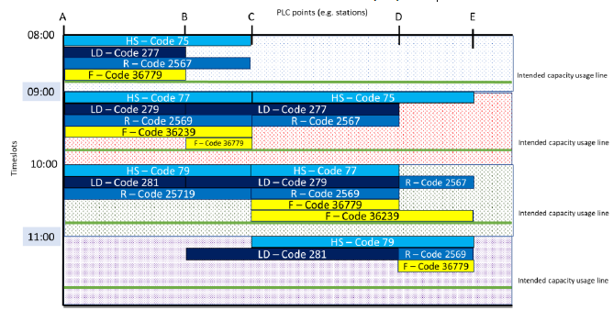

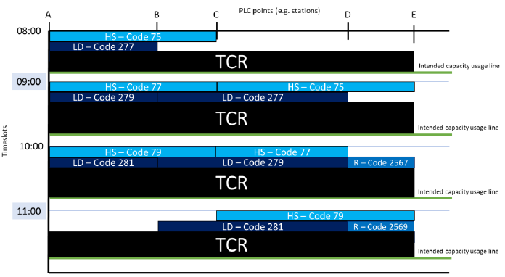

- Capacity objects overview between two PLCs (segment) – timeslot diagram

Each of the traffic volumes can be displayed as a single train run (square) or package of future slots (rectangle) per direction.

The visualization of the segment will be provided with an example.
For example: an IM displays ATT (freight & passenger) and RP volumes. The railway line A à C can be divided into two parts (A à B, B à C). The intended capacity usage line is based on historical data stemming from TIS/national traffic management system (explained in the topic “Inclusion of the intended capacity usage line” above).

The first Capacity Model (A à B) contains those trains, which pass (origin / run through) the first measuring point at point A, and run towards point B independently from the destination (B or C).
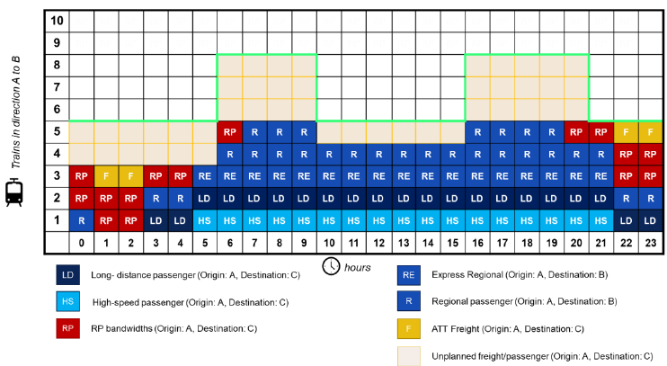
Figure 12 - Capacity Model (A à B)

The second Capacity Model (B à C) contains those trains, which pass (origin / run through) the first measuring point at point B and run towards point C independently from the origin (A or B).

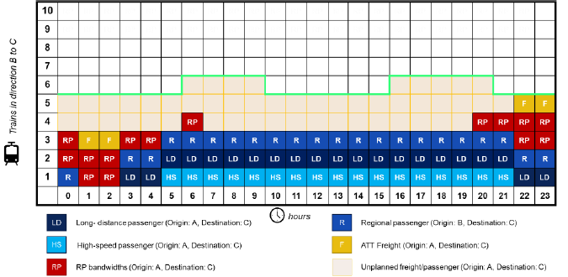
Figure 13 - Capacity Model (B à C)

The third Capacity Model (A à C) contains those trains, which pass (origin / run through) the first measuring point at point A, and run towards the destination at point C.

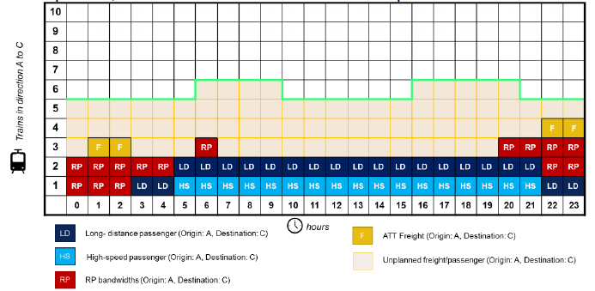
Figure 14 - Capacity Model (A à C)

In the case of the TCR window, planned from midnight to 06.00 AM, meaning a total closure over this period.

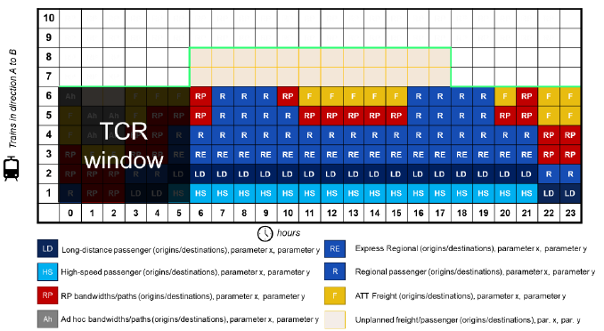
Figure 15 - Capacity Model with included TCR window

In the case of a partial closure on the section (e.g., 60 days of 186 volumes 114 are affected with this TCR, which means that this is a Major TCR:

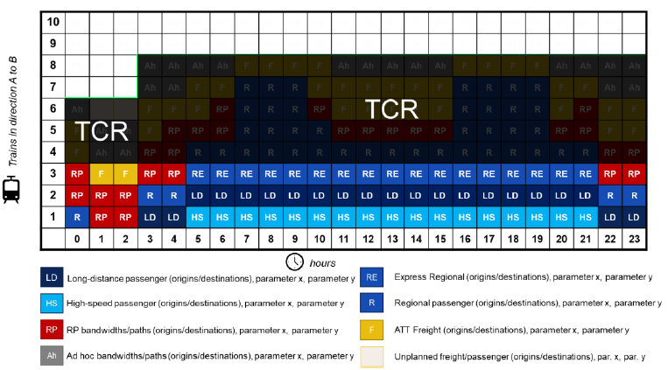
Figure 16 - Capacity Model with partial TCR closure

Requirements

The requirements that must be fulfilled regarding the visualization of the Capacity Model are the following:
- There is a need for a network map that provides a general overview (e.g., complete Europe), and with a possibility to view general information from all train path line sections already in the network map for instance number of RP slots daily (figure 1). This goes together with the filtering function (type of traffic, period, 24-hour pattern)
- In the network, a map should be possible to select particular line, which would open the detailed capacity model for that particular section.
- It should be possible to search for sections and combine them into an origin-destination overview, including all possible relevant routings.

The IT tool (ECMT) functionality of the Capacity Model should be able to combine the Capacity Models of the train path line sections and display overviews for complete lines, corridors, and whole networks.

Annexes

Annex 1: Capacity Model – Requirements for the central side (ECMT) implementation

Existing ECMT menu shall be changed and extended with new items:
- Capacity Model chart – item shall be added for a visualisation of the capacities defined in the Capacity Models
- Capacity Model – the item to be added to the Data menu with the following sub-menus
  - Import – for importing Capacity Model data using the excel structure
  - Manual creation – for opening the Capacity Model creation form for manual creation or change data
- Capacity Supply chart – the existing “ECM chart” shall be renamed

A form for manual Capacity Model data shall be created. The form contains 3 panes:
- Model pane – to define a basic Capacity Model data
- Details pane – to define capacity volumes
- Content pane – the list of already defined capacity volumes for the Capacity Model

The model pane has the basic information needed to describe the model itself, with the following data:
- The referenced Timetable year
- Train path line section for which model is created, which includes From, To and Via (waypoint) locations
- Category of the line (national or international)
- Visualisation of the train path line section on the map. There is also the possibility to select the train path line section on the map itself, by selecting locations and defining the route on the map

Together with the basic data, information about the date of creation and the user who created a model will be saved.

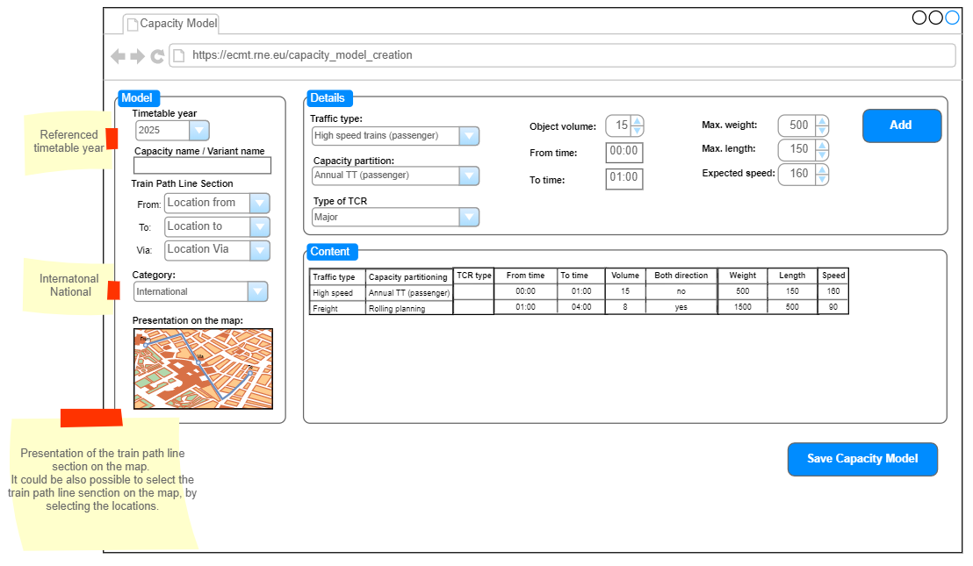
Figure 17 - Capacity Model manual creation form

The Details pane is used to enter the detailed data needed for capacity partition, like traffic type, capacity partition, volumes, period of time in a 24-hour, weight, length, speed.

After adding all needed values, a new record with entered data is presented in the content pane.

The Content pane presents all entered volumes for the Capacity Model for all capacity partitions.

After data is entered, by clicking the “Save Capacity Model” button, the user saves the model to the database. It will be possible to later to do changes on the saved model if needed.

Using the “Capacity Model chart” function, it is possible to filer Capacity Model data and visualize them on the form (figure 12).
The possible routes from origin to destination throughout the selected waypoint (if selected) will be drawn on the map. On each train path line section on the route will be presented several planned capacity objects. In the case that a specific object is filtered (like rolling planning in the figure below), the number on the train path line section presents the number of this object. In the case that the specific object is not filtered, then the number shows the amount of all planned objects on the train path line section.

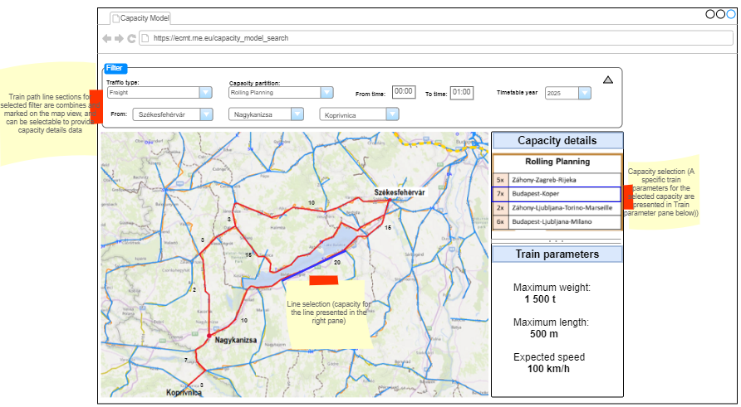
Figure 18 - Visualization of the Capacity Model data

By clicking the train path line section, details will be presented on the right side of the screen. In the case of a specific object filtering, the information related to this object will be shown. If the filtering object (capacity partition filter) is not selected then the capacity details will present the list of all planned objects for the selected train path line section in the expandable/collapsable panel, and by clicking the panel detailed information for the object will be shown.
The train path line selection that is selected will be presented in a different colour (like blue) than the others that are not selected.

Annex 2: Capacity Needs Announcements – Requirements for the central side (ECMT) implementation

General

- An additional functionality „Capacity Needs Announcements” shall be added to the ECMT main menu.
- A sub-menu opens:
  - Import CNA (import CNAs from excel file)
  - Create new CNA (create CNA manually)
  - My CNAs (management of already imported, created and submitted CNAs)

My CNAs (dashboard)

- The dashboard provides a table-overview of all CNAs created by the particular company and for those for which the company was nominated by another leading applicant.
- Search, advance search, ordering functionalities are provided
- In the table overview, the user can customise which columns (data) are essential and open the particular CNA for more details and editing.
- Selected CNAs should be exportable in the standardised form
- The user can select multiple CNAs and duplicate them. The system should ask before the duplication, which set of data should be duplicated (if all, or only the route/O/D etc). The user should be able to select another TT-period (duplicate is created but for another TT-period - carry forward solution).
- The user can select multiple CNAs and submit them to IMs or delete them.
- Buttons create CNA and import CNA should be also in the dashboard

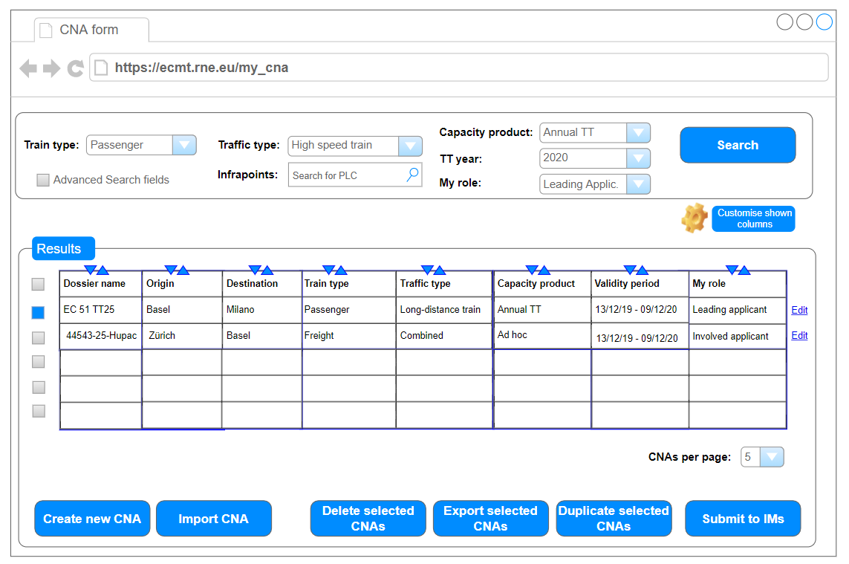

Creating/Editing a CNA

- Once the CNA is either imported or saved for the first time (manual creation) it appears in the My CNAs database (see below)
- Each CNA should have a status: at least two are needed: draft (under elaboration) or submitted (sent to IMs).
- The CNA in the draft can be saved at any time.
- Each CNA can be duplicated. The system should ask before the duplication, which set of data should be duplicated (if all, or only the route/O/D etc). The user should be able to select another TT-period (duplicate is created but for another TT-period - carry forward solution).
- The structure of the CNA follows the standardised format. Data input fields should be as much as possible based on the agreed content for TAF/TAP messages and fields already in ECMT. The data fields are not considered mandatory. Applicants can fill in the information in a general way or provide more details.
- Infrastructure points are defined by PLC. Origin and destination are mandatory. The leading applicant can add more waypoints to indicate the wished route, parameters and activities at certain infrastructure points. A partner applicant can be nominated for sections between infrastructure points (see access rights below).
- For each CNA the light system as in PCS is to be developed (green=work done, blue=work not started, yellow=work ongoing, red=applicant does not wish to participate anymore). Each involved applicant can set the light for its part. The green light is not a requirement for the CNA submission. A light system is also proposed for IMs in the later development (green=CNA fully considered, blue=CNA not processed yet, yellow=not fully considered and alternative proposed, red=CNA rejected – reasons explained in the CNA).
- Each CNA should include a conversation, where IMs and applicants can exchange comments. A notification should be sent to an email if someone places a comment.

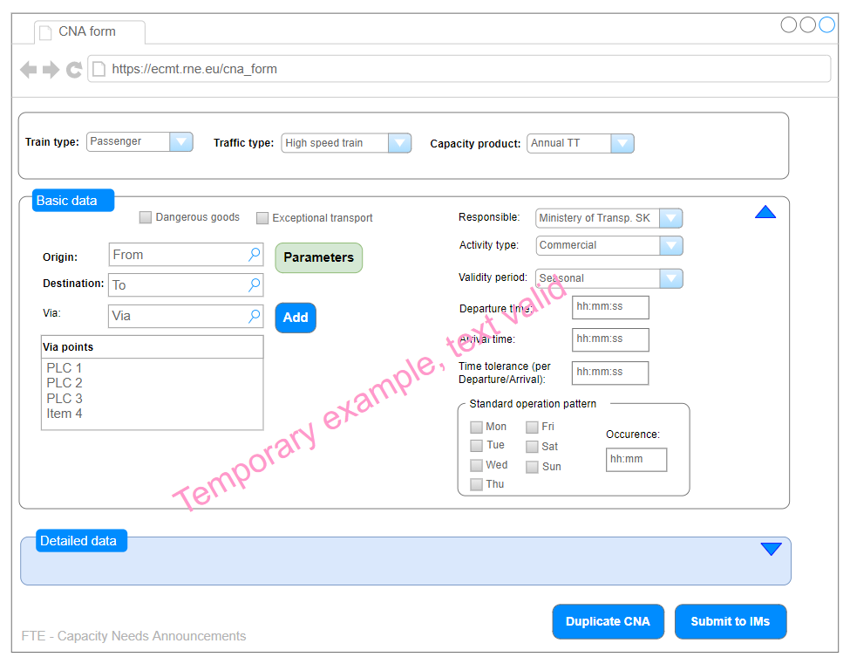

Access rights and applicant nominations

- The users within one company should have rights to manage all CNAs for their company (create, read, update, delete).
- The creator of the CNA will become by default the leading applicant. The leading applicant should have rights to give access for any geographical area (section between any infra points) to an applicant from another company, and also withdraw this access. The selected applicant will upon nomination get the rights to read and update the particular CNA, either whole or the selected section. The leading applicants should keep the editing rights for the section the nomination was provided.
- The delegation of the access rights for a section is not limited only to draft CNAs (X-24) but can be done even after the submission of the CNA. By this, the nominated applicant becomes the contact point for the respective IM in further consultations.
- Each CNA should keep the information which user created it, edit it and which companies have been nominated for which sections.

Others

- ECMT should track the versioning of the CNAs – similar to PCS. The development should count with the fact that KPIs are to be developed in the future to for instance compare CNA data to CM/CS, CNA data to path requests and train run data.
- For each CNA, a primary-contact should be defined per involved company – the user data such as phone/email helps in case something is needed by other parties and to receive notifications. The email/phone should be part of the user management of ECMT. It is assumed that in the future the system for TCR consultation purposes should recognise which CNAs conflict with (or are concerned by) a TCR on a certain route – this should help to identify the relevant companies and invite them to meetings/ECMT discussion.
- After X-24 and submission of the CNA, it should be still possible to withdraw or update the CNA with new information. Nonetheless, if any information already provided is changed, this must be documented and all involved partners and IMs notified since new CNAs and significant CNA updates might be not fully considered by IMs. Nevertheless, it is still better to submit a CNA after the deadline than not at all, so the system should allow it. The CNAs submitted after X-24 shall be marked and searchable. In the future ECMT should allow to define what is and what is not a significant CNA update (for instance change of transport type or nomination of a partner is not a significant change affecting the CM creation).
- A customisation of notification will be needed, the user should be able to set about what they want to be informed. A need detected for cases such as involved partner set green light, CNA submitted, IM answered, something changed in CNA after X-24 etc.
Proposed data structure
Data | Definition | Field type
Dossier name+ | Unique primary key | Open text
Action++ | What should happen with the row (PLC) once uploaded (upload, delete, no action) | Dropdown
Version++ | (only for export, for import to be empty) | Open text
Capacity product type | Annual TT, Rolling Planning, Ad Hoc | Dropdown
Type of transport | Passenger (high speed/long distance/express regional/regional), Freight (wagonload/blocktrain/combined transport) | Dropdown
Status quo | (empty, as in TT2022, as in TT2023 etc.) | Dropdown
Dangerous goods* | Yes/No | Checkbox
Exceptional transport* | Yes/No | Checkbox
Validity period | Yearly/Seasonal/Infrequent | Dropdown
Frequency of services | Weekly pattern/irregular | Checkboxes and additional Open Text
Standard operation pattern (clockphase scheduling yes/no and pattern)** | Yes/No | Choicebox
Traffic period | Calendar/TT-year/Traffic days | Choicebox and Dropdown or calendar
Origin+ | Primary location codes | Open text (PLC)
Destination+ | Primary location codes | Open text (PLC)
Via points | Primary location codes | Open text (PLC)
Responsible applicant (per PLC)+ | company | Dropdown
activity type (per PLC) | Activity types from PCS | Dropdown
Earliest arrival time (per PLC) | hh:mm | Time
Arrival Time (per PLC) | hh:mm | Time
Latest arrival time (per PLC) | hh:mm | Time
Earliest departure time (per PLC) | hh:mm | Time
Departure time (per PLC) | hh:mm | Time
Latest departure time (per PLC) | hh:mm | Time
Time tolerance (per PLC) | (∓ hh:mm), when used, makes obligatory either departure or arrival | Time
Max. journey time from origin to destination | hh:mm | Time
Max. running speed (per PLC) | km/h | Number
Max. weight (per PLC) | tons | Number
Max. train length (incl. Locos) (per PLC) | Meters | Number
Rolling stock type** | Composite/push-pull/EMU/DMU | Dropdown
Tilting | Yes/No | Checkbox
Number of locos (per PLC) |  | Number
ETCS onboard (per PLC) | Yes/No | Dropdown
Clearance profile (per PLC) | Meters | Number
Accelaration (per PLC) | m/s^2 | Number
Brake type/ratio (per PLC) | G, P, R etc. (from PCS) | Number
Traffic contracted?* | Yes/No | Dropdown
Type of contract/Comment (open text) for identification of double CNA* |  | Open text
Train number |  | Number
Train ID |  | Composite
+Compulsory fields
++ Only for XLSX import/export
*Freight only
**Passenger only

Import/Export sheet

- The excel sheet would probably require one row per PLC. Other user-friendly solutions are welcome. It can be assumed that some stakeholders will do the work/harmonisation in the excel file.
- Exported CNAs should contain the complete information from origin to destination, even the geographical area which is not in the responsibility of the applicant who did the export.
- Import back to the system should not allow update information for PLC not under the responsibility of the uploader (exception the leading applicant). In the import should be possible to mark which PLC rows are subject to update – to avoid that the leading applicant overwrites the data for the territory where another applicant was delegated.

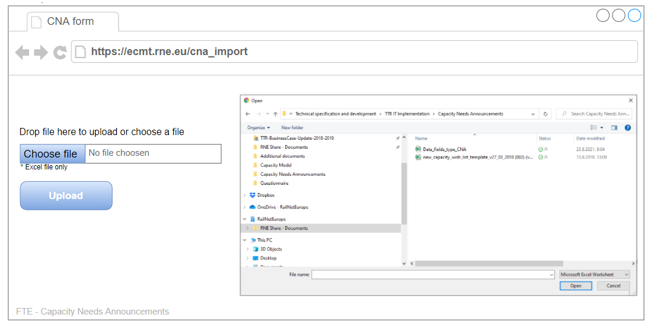

Annex 3: Capacity Model import template

The below table contains the basic set of information, which should be uploaded into the ECMT for the preparation of the Capacity Models.

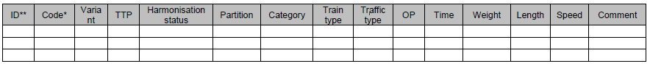
* Code: Train number, or any kind of unique identification of the object
** ID: row number

Annex 4: Excel data structure for the Capacity Model import (including samples and description)

Annex 5: Excel data structure for inclusion of the intended capacity usage line

It defines necessary data for the definition of the intended capacity usage line that will be imported considering the historical data of TIS or the national traffic management system.

Location from | Location to | Period from | Period to | Time | Number of trains

Annex 6: Excel and XML template structure for importing the TCRs, including the TCR message description and schema

Link: https://cms.rne.eu/system/files/ttr_it_landscape_-_technical_specification_v2.0_2021-12-07_2.pdf
Link: https://cms.rne.eu/system/files/ttr_it_landscape_-_technical_specification_v1.0_-_published_3.pdf
Link: https://cms.rne.eu/system/files/hb_capacity_model_1.0_2021-12-07_2.pdf
Link: https://cms.rne.eu/system/files/hb_tcr_1.0_2021-12-07_2.pdf

